For Academic Affairs and Research Use Only
CIP Code:
Degree Code:

Reconfiguration of Existing Degree Program Proposal Form
[ ] Undergraduate Curriculum Council
[X] Graduate Council
Signed paper copies of proposals submitted for consideration are no longer required. Please type approver name and enter date of approval.
Email completed proposals to curriculum@astate.edu for inclusion in curriculum committee agenda.
Department Curriculum Committee Chair | COPE Chair (if applicable)
  Edward Hammerand | 9/27/2017
  __________________ | Enter date
Department Chair: | Head of Unit (If applicable)
  Hung-Chi Su | 9/27/2017
  __________________ | Enter date
College Curriculum Committee Chair | Undergraduate Curriculum Council Chair
  David F. Gilmore | 10/6/2017
  __________________ | Enter date
College Dean | Graduate Curriculum Committee Chair
  Anne A. Grippo | 10/6/2017
  __________________ | Enter date
General Education Committee Chair (If applicable) | Vice Chancellor for Academic Affairs
  __________________ | Enter date
  __________________ | Enter date

- Proposed Program Title
Graduate Certificate in High Performance Computing

- Contact Person (Name, Email Address, Phone Number)
Dr. Hung-Chi Su, suh@astate.edu, 870-680-8119

- Proposed Starting Date
Spring 2018

- Is there differential tuition requested? If yes, please fill out the New Program/Tuition and Fees Change Form.
No
Bulletin Changes

Instructions
Please visit http://www.astate.edu/a/registrar/students/bulletins/index.dot and select the most recent version of the bulletin. Copy and paste all bulletin pages this proposal affects below. Follow the following guidelines for indicating necessary changes.

*Please note: Courses are often listed in multiple sections of the bulletin. To ensure that all affected sections have been located, please search the bulletin (ctrl+F) for the appropriate courses before submission of this form.

- Deleted courses/credit hours should be marked with a red strike-through (red strikethrough)
- New credit hours and text changes should be listed in blue using enlarged font (blue using enlarged font).
- Any new courses should be listed in blue bold italics using enlarged font (blue bold italics using enlarged font)

You can easily apply any of these changes by selecting the example text in the instructions above, double-clicking the ‘format painter’ icon , and selecting the text you would like to apply the change to.
Please visit https://youtu.be/yjdL2n4lZm4 for more detailed instructions.

*For new programs, please insert copy of all sections where this is referenced.*

Insert Page 52 of 2017-18 Graduate Bulletin under Graduate Certificates:

Educational Leadership
—Building Level Administration
—Curriculum Director
—Gifted, Talented and Creative Director
—Instructional Specialist - Gifted, Talented
and Creative
—K-12 Special Education
—Special Education Director
Dyslexia Therapy
History
Health Care Management
Health Communication
Healthcare Emergency Management
Health Sciences Education
Clinical Mental Health Counseling
Nurse Educator
Play Therapy
High Performance Computing

Insert Page 244 of 2017-18 Graduate Bulletin:

The College of Sciences and Mathematics offers work leading to the Master of Arts degree in biology; to the Master of Science degree with majors in biology, chemistry, computer science, environmental sciences, and mathematics; to the Master of Science in molecular biosciences; to the Master of Science in Education degree with majors in biology, chemistry, and mathematics; and to the Graduate Certificate in High Performance Computing.

Insert Page 262 of 2017-18 Graduate Bulletin After Program of Study for M.S. Computer Science:

University Requirements:
See Graduate School Degree Policies for additional information (p. 35)

Program Requirements: Sem. Hrs.
CS 6213, Parallel Processing 3
CS 6243, Heterogeneous Computing 3
CS 6253, Distributed Systems 3

Electives: 6
Select six hours from the following:
CS 5223, Unix Systems Programming
CS 6223, Advanced Computer Architecture
CS 6233, Operating System Design
CS 6263, Cloud Computing

Total Required Hours: 15

LETTER OF NOTIFICATION – 11
RECONFIGURATION OF EXISTING DEGREE PROGRAMS
(Consolidation or Separation of Degrees to Create New Degree)
*Please include the documents to be submitted found throughout this LON at the end of the form.

- Institution submitting request: Arkansas State University

- Contact person/title: Dr. Hung-Chi Su, Chair of Computer Science Department

- Title(s) of degree programs to be consolidated/reconfigured:
Master of Science in Computer Science

- Current CIP Code(s)/Current Degree Code(s): 11.0101

- Proposed title of consolidated/reconfigured program: Graduate Certificate in High Performance Computing

- Proposed CIP Code for new program: 11.0301

- Proposed Effective Date: Spring 2018

- Reason for proposed program consolidation/reconfiguration:
(Indicate student demand (projected enrollment) for the proposed program and document that the program meets employer needs)

Reconfiguring the M.S. in Computer Science degree to create a graduate certificate in High Performance Computing. The courses will be pulled from the MS Computer Science Elective courses.
There is a rising demand for students who have expertise in High Performance Computing from corporations, nonprofit companies, agencies and educational institutions.
The projected enrollment will be 35 students per section.
http://forecasting.tstc.edu/techbriefs/high-performance-computing/
Technology has shifted from supercomputers to clusters and grids of commercial off-the-self microcomputers, and thus moving HPC into the mainstream marketplace through business, education, government, and the military. This shift has, in turn, created a demand for HPC technicians, who are in short supply.
Students graduating with HPC skills will have job opportunities across education, military, government, and industry sectors.

http://www.sciencemag.org/careers/2012/03/data-deluge-drives-demand
As researchers produce more and more data to crunch, national labs and university-affiliated supercomputer centers are expanding and building new supercomputers, which need more and more computer scientists with high-performance computing skills to program and operate them.
"We are certainly having trouble finding people with the appropriate skills,” says William Gropp, a professor of computer science at the University of Illinois, Urbana-Champaign, which is installing a new supercomputer called Blue Waters. “Everyone that I’ve spoken to has said that hiring is a problem.”

- Provide current and proposed curriculum outline by semester.
For undergraduate programs, please also fill out 8-semester plan at end of document.
Indicate total semester credit hours required for the proposed program. Underline new courses and provide new course descriptions. (If existing courses have been modified to create new courses, provide the course name/description for the current/existing courses and indicate the related new/modified courses.) Identify required general education core courses with an asterisk.

Current M.S. in Computer Science Curriculum
M.S. Computer Science
Course Number | Course Title | Credit Hours
CS 5713 | Analysis of Algorithms | 3
Select One of the Following
CS 5133 | Compiler | 3
CS 5723 | Automata Theory | 3
Select One of the Following
CS 5313 | Computer Networks | 3
CS 6213 | Parallel Processing
CS 6243  (pre fall 2017 #s were 6233 & 6823) | Distributed Systems
CS 6253  (pre fall 2017 #s were 6223 & 6823) | Heterogeneous Computing  (pre fall 2017 name was High Performance Computing)
Computer Science Electives (Choose 18 hours)
CS Elective |  | 18
CS Elective |  | 18
CS Elective |  | 18
CS Elective |  | 18
CS Elective |  | 18
CS Elective |  | 18
CS/MATH/STAT Electives (Choose 6 hours)
CS/MATH/STAT Elective |  | 6
CS/MATH/STAT Elective |  | 6

Proposed Graduate Certificate in High Performance Computing

Course Number | Course Title | Credit Hours
Semester 1
CS 6213 | Parallel Processing | 3
Semester 2
CS 6253 | Heterogeneous Computing | 3
Semester 3
CS 6243 | Distributed Systems | 3
Semester 4
Choose Two Electives (6 hours)
CS 5223 | Unix Systems Programming | 6
CS 6223 | Advanced Computer Architecture | 6
CS 6233 | Operating System Design | 6
CS 6263 | Cloud Computing | 6
Total Credit Hours |  | 15
New courses:
- CS 6243, Distributed Systems (offered to date as a special topics subject, CS6823)
Advanced topics on distributed computing systems including computing models, cluster computing, grid computing, service computing, virtual machines, computing in the cloud, peer-to-peer computing and major distributed algorithms.
- CS 6253, Heterogeneous Computing (offered to date as a special topics subject, CS6823)
The study of the ecosystem of co-processing elements such as the Graphics Processing Unit or GPU in modern computing systems, covering hardware architecture, software design, the programming paradigm, and related libraries.
- CS 6223, Advanced Computer Architecture (offered to date as a special topics subject, CS6823)
Advanced topics on computer architecture, including: memory hierarchy design; instruction-level parallelism in pipelines; data-level parallelism in vector, SIMD and GPU architectures; thread-level parallelism; warehouse-scale computers.
- CS 6233, Operating System Design (offered to date as a special topics subject, CS6823)
Advanced topics on the design and implementation of major operating systems, including memory management, kernel data structures, process management, file systems, devices and modules.
- CS 6263, Cloud Computing
Major aspects of the cloud ecosystem including conceptual basis, design, virtualization, architecture, storage, programming paradigms, and software development.

- Provide program budget. Indicate amount of funds available for reallocation.
See end of document.

- Provide current and proposed organizational chart. See end of document.

- Institutional curriculum committee review/approval date: Enter text...

- Are the existing degrees offered off-campus or via distance delivery? No

- Will the proposed degree be offered on-campus, off-campus, or via distance delivery?
On-campus

- Identify mode of distance delivery or the off-campus location for the proposed program.
N/A

- Provide documentation that proposed program has received full approval by licensure/certification entity, if required.
(A program offered for teacher/education administrator licensure must be reviewed/approved by the Arkansas Department of Education prior to consideration by the Coordinating Board; therefore, the Education Protocol Form also must be submitted to ADHE along with the Letter of Notification).

N/A, program does not lead to licensure/certification

- Provide copy of e-mail notification to other institutions in the area of the proposed program and their responses; include your reply to the institutional responses. See end of document.

- List institutions offering similar program and identify the institutions used as a model to develop the proposed program.
The George Washington University – Graduate Certificate in High Performance Computing
University of Illinois at Urbana-Champaign – Undergraduate Certificate in High Performance Computing
Michigan State University – Graduate Certificate in High Performance Computing
Kennesaw State University – Graduate Certificate in High Performance Computing Clusters

Model used to develop program was the A-State M.S. in Computer Science program
- Provide scheduled program review date (within 10 years of program implementation).
Spring 2028

- Provide additional program information if requested by ADHE staff.
Enter text...

President/Chancellor Approval Date: Click here to enter a date.
Board of Trustees Notification Date: Click here to enter a date.

Chief Academic officer: ___________________________________ Date: Enter date.
Name (printed): Click here to enter text.

8-Semester Plan
(referenced in #9 - Undergraduate Proposals Only)
Instructions: Please identify new courses in italics.
Arkansas State University-Jonesboro Degree:
Major:
Year:

Students requiring developmental course work based on low entrance exam scores (ACT, SAT, ASSET, COMPASS) may not be able to complete this program of study in eight (8) semesters. Developmental courses do not count toward total degree hours. Students having completed college level courses prior to enrollment will be assisted by their advisor in making appropriate substitutions. In most cases, general education courses may be interchanged between semesters. A minimum of 45 hours of upper division credit (3000-4000 level) is required for this degree.
Year 1 |  |  |  |  | Year 1
Fall Semester |  |  |  |  | Spring Semester
Course No. | Course Name | Hrs | Gen Ed |  | Course No. | Course Name | Hrs | Gen Ed
Total Hours |  |  |  |  | Total Hours
Year 2 |  |  |  |  | Year 2
Fall Semester |  |  |  |  | Spring Semester
Course No. | Course Name | Hrs | Gen Ed |  | Course No. | Course Name | Hrs | Gen Ed
Total Hours |  |  |  |  | Total Hours
Year 3 |  |  |  |  | Year 3
Fall Semester |  |  |  |  | Spring Semester
Course No. | Course Name | Hrs | Gen Ed |  | Course No. | Course Name | Hrs | Gen Ed
Total Hours |  |  |  |  | Total Hours
Year 4 |  |  |  |  | Year 4
Fall Semester |  |  |  |  | Spring Semester
Course No. | Course Name | Hrs | Gen Ed |  | Course No. | Course Name | Hrs | Gen Ed
Total Hours |  |  |  |  | Total Hours
Total Jr/Sr Hours ___ Total Degree Hours ___
Graduation Requirements:

Program Budget
(referenced in # 10)

Provide program budget. Indicate amount of funds available for reallocation.

All but one of the courses involved are already being taught as special topics; the rotation will be revised to provide an opening for the one new course. Consequently, there will be no extra funds required.

Organizational Chart
(referenced in # 11)

Provide current and proposed organizational chart. Include where the proposed program will be housed (department/college).

Organizational Chart will remain the same.

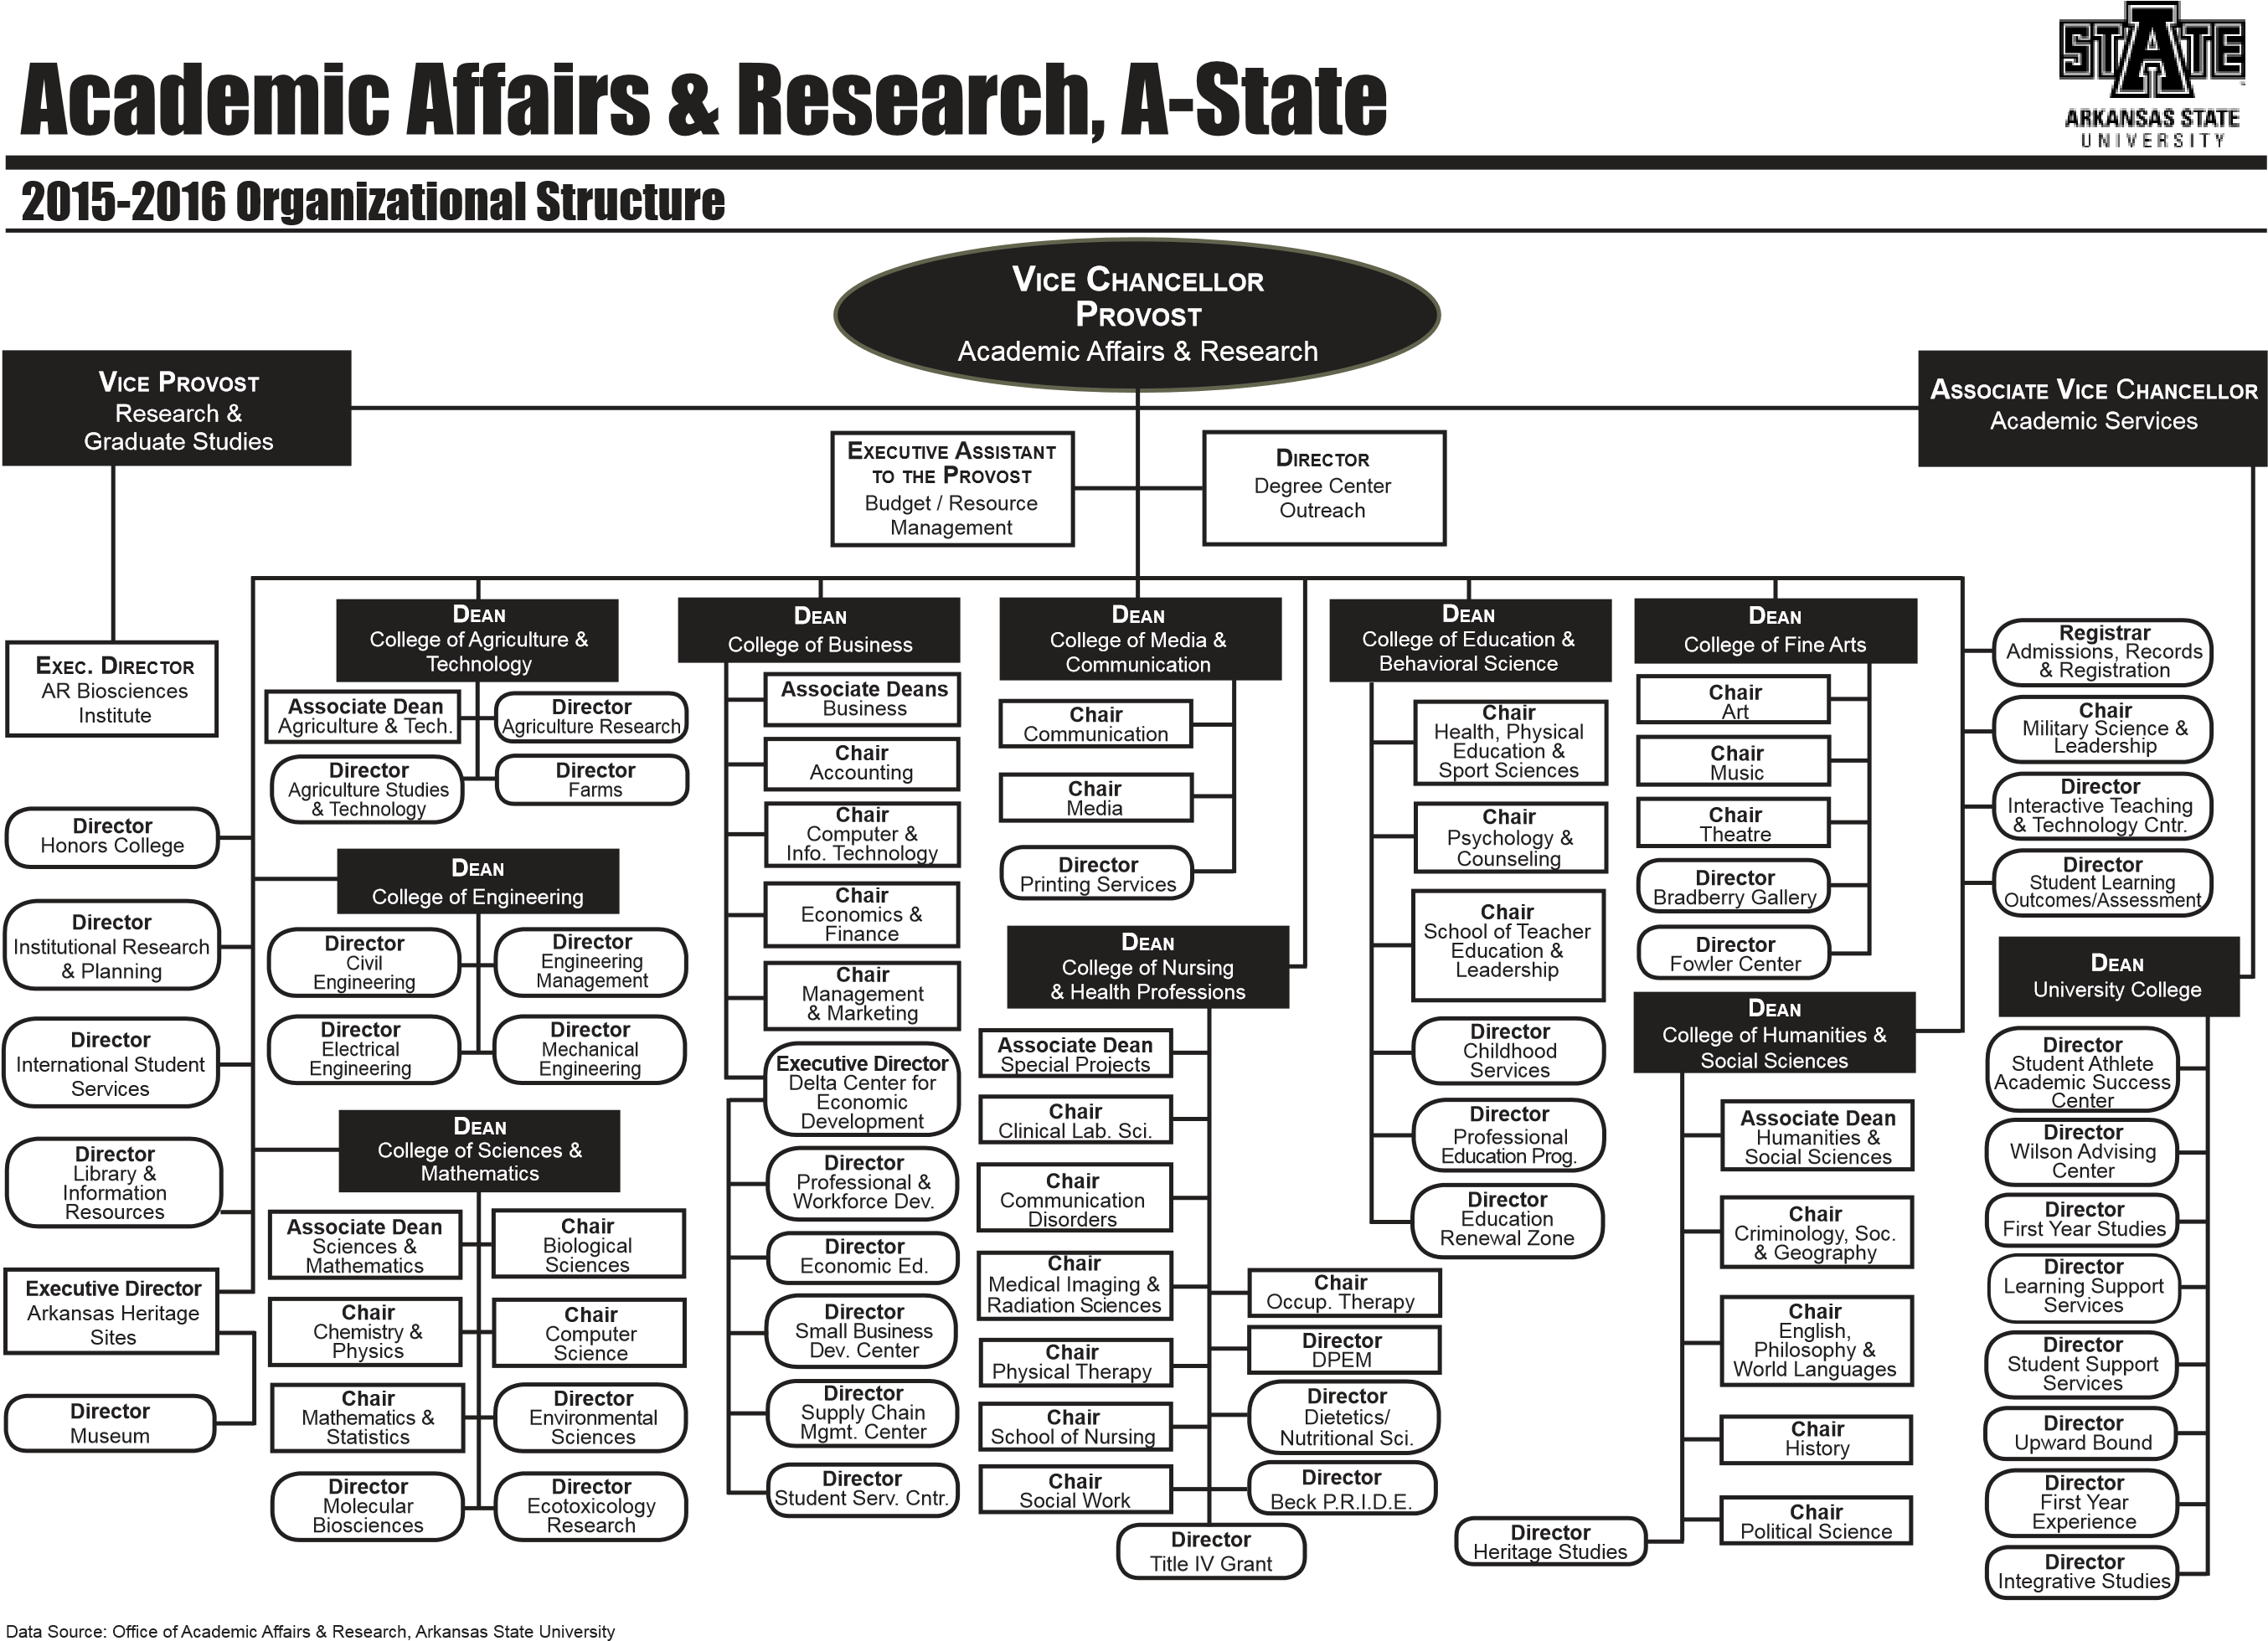

Written Notification to Other Institutions
(referenced in # 17)

This should include a copy of written notification to other institutions in area of proposed program and responses

According to the office of Vice Chancellor for Academic Affairs, this is not required for this certificate

Student Learning Outcomes
Provide outcomes that students will accomplish during or at completion of this reconfigured degree. Fill out the following table to develop a continuous improvement assessment process.
For further assistance, please see the ‘Expanded Instructions’ document available on the UCC - Forms website for guidance, or contact the Office of Assessment at 870-972-2989.
Note: Best practices suggest 4-7 outcomes per program; minors would have 1 to 4 outcomes.
Outcome 1 | A deeper understanding of the theory and application of high performance computing algorithms and processes.
Assessment Procedure Criterion | Comprehensive examinations and employer surveys
Which courses are responsible for this outcome? | CS 5223, Unix Systems Programming  CS 5313, Computer Networks  CS 6213, Parallel Processing  CS 6223, Advanced Computer Architecture  CS 6233, Operating System Design  CS 6243, Distributed Systems  CS 6253, Heterogeneous Computing  CS 6263, Cloud Computing
Assessment  Timetable | Comprehensive exams will be conducted each semester, reviewed annually, and reported on every three years; employer surveys will be conducted each fall and reported on every four years.
Who is responsible for assessing and reporting on the results? | Department assessment committee

Outcome 2 | The ability to apply high performance analysis techniques to problem identification.
Assessment Procedure Criterion | Comprehensive examinations and employer surveys
Which courses are responsible for this outcome? | CS 6213, Parallel Processing  CS 6223, Advanced Computer Architecture  CS 6233, Operating System Design  CS 6243, Distributed Systems  CS 6253, Heterogeneous Computing  CS 6263, Cloud Computing
Assessment  Timetable | Comprehensive exams will be conducted each semester, reviewed annually, and reported on every three years; employer surveys will be conducted each fall and reported on every four years.
Who is responsible for assessing and reporting on the results? | Department assessment committee

Outcome 3 | The ability to apply high performance computing implementation techniques to problem solution.
Assessment Procedure Criterion | Comprehensive examinations and employer surveys
Which courses are responsible for this outcome? | CS 6213, Parallel Processing  CS 6223, Advanced Computer Architecture  CS 6233, Operating System Design  CS 6243, Distributed Systems  CS 6253, Heterogeneous Computing  CS 6263, Cloud Computing
Assessment  Timetable | Comprehensive exams will be conducted each semester, reviewed annually, and reported on every three years; employer surveys will be conducted each fall and reported on every four years.
Who is responsible for assessing and reporting on the results? | Department assessment committee

Please repeat as necessary.

