For Academic Affairs and Research Use Only
Proposal Number | BU11
CIP Code:
Degree Code:

Program Modification Form
[x ] Undergraduate Curriculum Council
[ ] Graduate Council
Modification Type: [ ]Admissions, [ ]Curricular Sequence, or [ ]Other

Signed paper copies of proposals submitted for consideration are no longer required. Please type approver name and enter date of approval.

Department Curriculum Committee Chair | COPE Chair (if applicable)
  __________________ | Enter date
  __________________ | Enter date
Department Chair | Head of Unit (if applicable)
  __________________ | Enter date
  __________________ | Enter date
College Curriculum Committee Chair | Undergraduate Curriculum Council Chair
  __________________ | Enter date
  __________________ | Enter date
Director of Assessment (only for changes impacting assessment) | Graduate Curriculum Committee Chair
  John Robertson | 3/11/2022
  __________________ | Enter date
College Dean | Vice Chancellor for Academic Affairs
  Jim Washam | 3/25/2022
  __________________ | Enter date
__________________ | Enter date
General Education Committee Chair (if applicable)

- Contact Person (Name, Email Address, Phone Number)
Dr. Melodie Philhours
mphil@astate.edu
870-680-8148

- Proposed Change (for undergraduate curricular changes please provide an 8-semester plan (appendix A), if applicable)
In a separate proposal, GSCM 3163 Global Supply Chain Management will replace MGMT 2003 Entrepreneurial Discovery in the NGCOB core curriculum. Because an upper-level course is replacing a lower-level course in the core, the upper-level elective is no longer a needed requirement to achieve 45 upper-level hours. This proposal eliminates the “(must include 3 upper-level hours)” wording from the Electives section of the following degree plans:

Business Administration – Sustainable Business Practices Emphasis
Economics – BS
Finance – Financial Management Emphasis
Global Supply Chain Management
Management
Management – Hospitality Emphasis
Management – HR Management

- Effective Date
Fall 2022

- Justification – Please provide details as to why this change is necessary.
As an upper-level course replaced a lower-level course in the core, these 3 hours of upper-level electives are no longer needed to achieve the 45 upper-level hours required for these degrees. The number of elective hours remains consistent but may be “Any Elective” at any level.

Bulletin Changes

Instructions
Please visit http://www.astate.edu/a/registrar/students/bulletins/index.dot and select the most recent version of the bulletin. Copy and paste all bulletin pages this proposal affects below. Please include a before (with changed areas highlighted) and after of all affected sections.

*Please note: Courses are often listed in multiple sections of the bulletin. To ensure that all affected sections have been located, please search the bulletin (ctrl+F) for the appropriate courses before submission of this form.

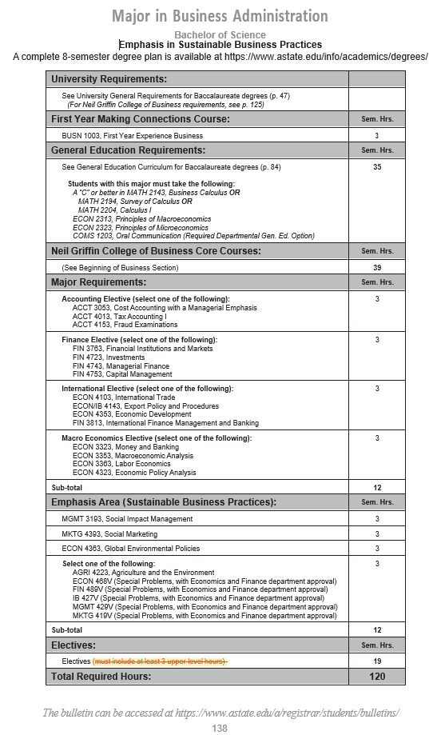
Reorder to Alphanumeric Order:

Emphasis Area (Sustainable Business Practices):
ECON 4383, Global Environmental Policies
MGMT 3193, Social Impact Management
MKTG 4393, Social Marketing

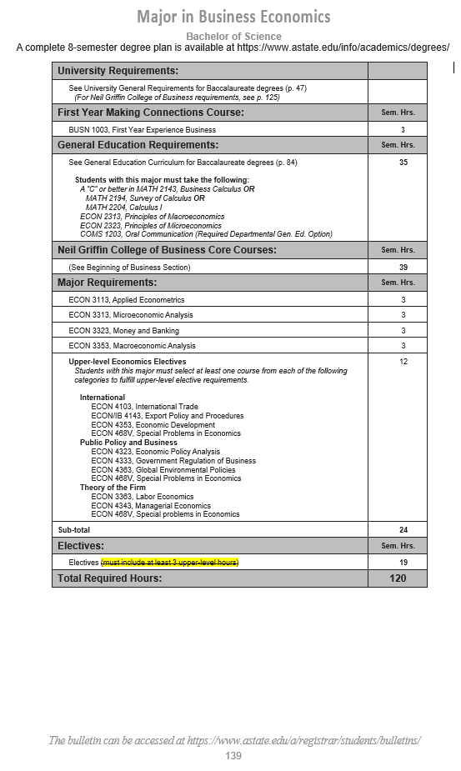
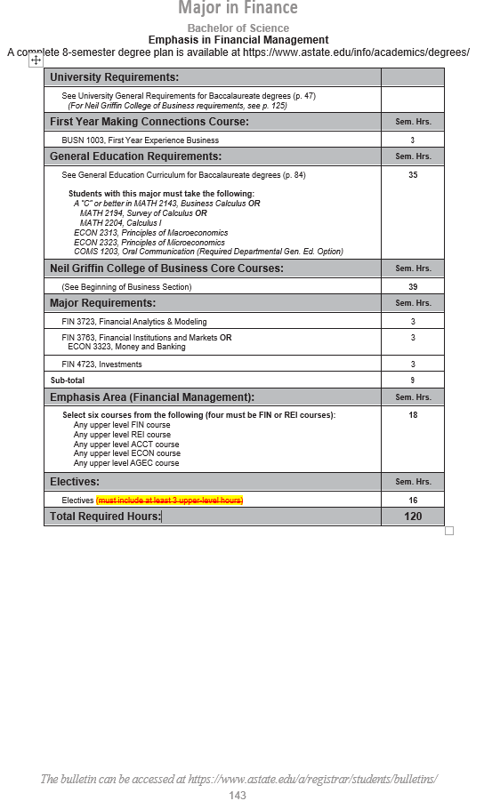
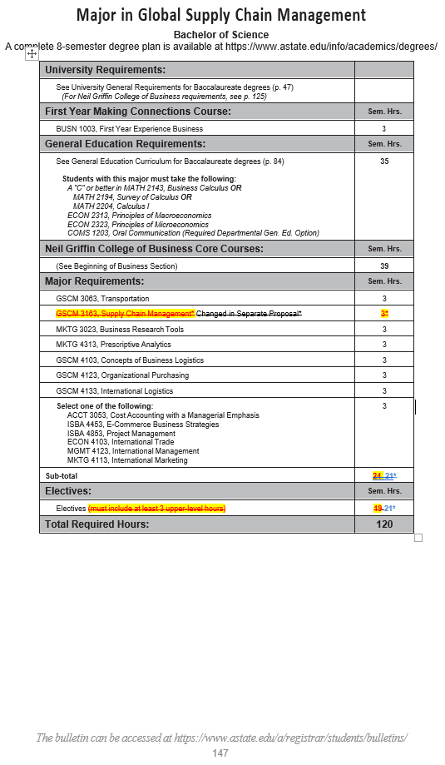
22
See alpha-numeric reordering of Major Requirements below.
Major Requirements: | Sem. Hrs.
GSCM 3063, Transportation | 3
GSCM 4103, Concepts of Business Logistics | 3
GSCM 4123, Organizational Purchasing | 3
GSCM 4133, International Logistics | 3
MKTG 3023, Business Research Tools | 3
MKTG 4313, Prescriptive Analytics | 3
Select One of the Following:  ACCT 3053, Cost Accounting with Managerial Emphasis  ECON 4103, International Trade  ISBA 4453, E-Commerce Business Strategies  ISBA 4853, Project Management  MGMT 4123, International Management  MKTG 4113, International Marketing | 3
Sub-Total | 21
Electives (must include at least 3 upper level hours) | 22
Total Required Hours | 120

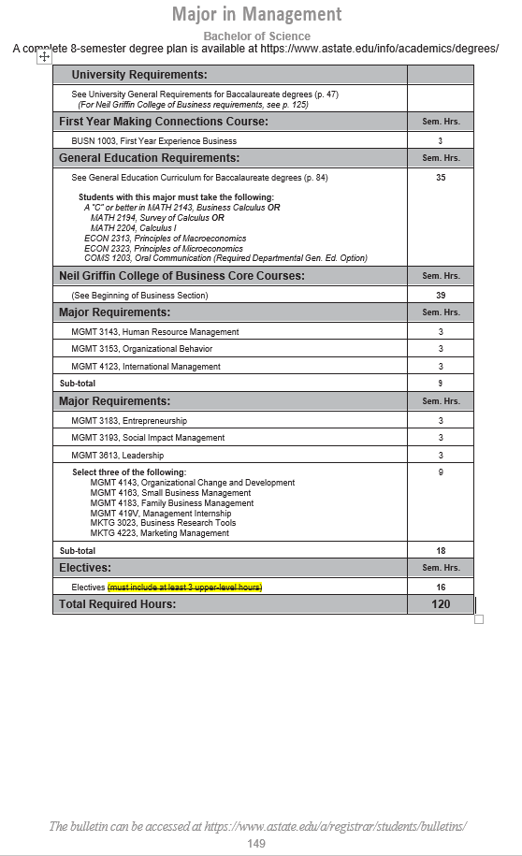
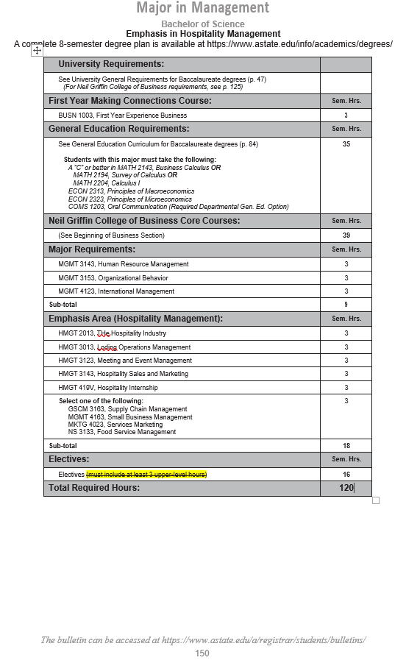
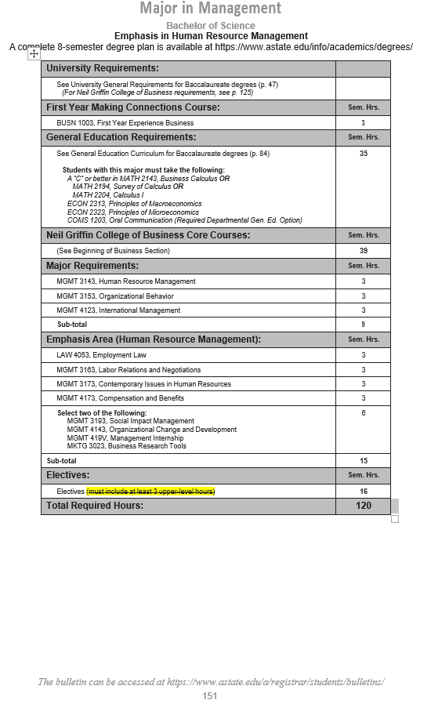

Appendix A, 8-Semester Plan
(Referenced in #2 - Undergraduate Proposals Only)
Instructions: Please identify new courses in italics.
Arkansas State University-Jonesboro
Degree:
Major:
Year:

Students requiring developmental course work based on low entrance exam scores (ACT, SAT, ASSET, COMPASS) may not be able to complete this program of study in eight (8) semesters. Developmental courses do not count toward total degree hours. Students having completed college level courses prior to enrollment will be assisted by their advisor in making appropriate substitutions. In most cases, general education courses may be interchanged between semesters. A minimum of 45 hours of upper division credit (3000-4000 level) is required for this degree.
Year 1 |  |  |  |  | Year 1
Fall Semester |  |  |  |  | Spring Semester
Course No. | Course Name | Hrs | Gen Ed |  | Course No. | Course Name | Hrs | Gen Ed
Total Hours |  |  |  |  | Total Hours
Year 2 |  |  |  |  | Year 2
Fall Semester |  |  |  |  | Spring Semester
Course No. | Course Name | Hrs | Gen Ed |  | Course No. | Course Name | Hrs | Gen Ed
Total Hours |  |  |  |  | Total Hours
Year 3 |  |  |  |  | Year 3
Fall Semester |  |  |  |  | Spring Semester
Course No. | Course Name | Hrs | Gen Ed |  | Course No. | Course Name | Hrs | Gen Ed
Total Hours |  |  |  |  | Total Hours
Year 4 |  |  |  |  | Year 4
Fall Semester |  |  |  |  | Spring Semester
Course No. | Course Name | Hrs | Gen Ed |  | Course No. | Course Name | Hrs | Gen Ed
Total Hours |  |  |  |  | Total Hours
Total Jr/Sr Hours ___ Total Degree Hours ___
Graduation Requirements:

