For Academic Affairs and Research Use Only
Proposal Number | LAC134
CIP Code:
Degree Code:

New Emphasis, Concentration, Option, or Minor Proposal Form
[X] Undergraduate Curriculum Council
[ ] Graduate Council
Signed paper copies of proposals submitted for consideration are no longer required. Please type approver name and enter date of approval.

Department Curriculum Committee Chair | COPE Chair (if applicable)
  Katherine Baker | 1/21/2022
  __________________ | Enter date
Department Chair | Head of Unit (if applicable)
  Temma Balducci | 1/21/2022
  __________________ | Enter date
College Curriculum Committee Chair | Undergraduate Curriculum Council Chair
  Warren Johnson 9/27/2022
  __________________ | Enter date
College Dean | Graduate Curriculum Committee Chair
  Gina Hogue | 9/28/2022
  __________________ | Enter date
General Education Committee Chair (if applicable) | Vice Chancellor for Academic Affairs
  __________________ | Enter date
  Alan Utter | 10/17/2022

- Contact Person (Name, Email Address, Phone Number)
Mindy Fulcher, Dept. of Art + Design, mfulcher@astate.edu, 870-761-2121

- Proposed Starting Date
Fall 2023

- Title of degree program:
Bachelor of Science in Digital Technology and Design

- Proposed name of new option/concentration/emphasis/minor:
Web Development Emphasis

- Reason for proposed action that includes rationale, goals, and student population served:
The Digital Technology and Design degree provides students a core education in Design Software Technology and Human Centered Design Theory combined with foundational programming logic. These skills develop students into creative problem solvers who also possess the necessary software skills to make an impact in a variety of Digital Technology and Design fields.
We feel that there is a growing interest among students to learn about Web Development and Back-End Programming to become qualified for new careers within this emerging industry. We believe that this content would fit well within the Digital Technology and Design degree and attract new students to the University. This new concentration area will provide students with more advanced knowledge, skills and portfolios in the field of Web Development. By providing students the ability to choose to specialize in a specific area of Digital Technology/Design, we develop stronger graduates who are better prepared for the career field.
A-State: BS Digital Technology and Design (Web Development) employment data and needs assessment research provided by Academic Partnerships.
Region: AR, TX, TN, LA, MS and MO
Conferrals for BS – Informational Technology were 839 in 2020, up 83.6% since 2016.
UX/ UI developers (field is also called Web Development)
- Employment for UX/ UI related occupations in the regions is projected to grow 21% over the next 10 years in the region
- In the last 12 months, 9,503 jobs related to UX/ UI design were posted in the region.
- Top 5 employers: IBM, Ad Hoc Team (digital services company servicing the federal government), Deloitte, JP Morgan Chase

- Provide the following:
  - Curriculum outline - List of courses in new option/concentration/emphasis/minor – Underline required courses
DIGI/ISBA 3243, Software Development Trends
DIGI/ISBA 3323, Front-End Frameworks
DIGI/ISBA 3333, Back-End Web Development
DIGI/ISBA 4243, Problem Solving with Python
ISBA 3033, Intermediate Programming
MATH 2013, Math for Computational Intelligence
  - Total semester credit hours required for option/emphasis/concentration/minor
18
  - Student demand (projected enrollment) for program option
10-25 per year

- Will the new option/emphasis/concentration/minor be offered:
  - Traditional/Face-to-face No
  - Distance/Online Yes
    - If yes, indicate mode of distance delivery, and the percentage of courses offered via this modality (<50%, 50-99%, or 100%).
100%
    - If online, will it be offered through Global Initiatives/Academic Partnerships (AP)?
YES
- Specify the amount of the additional costs required, the source of funds, and how funds will be used.
Adjunct cost would be $2000-$3500 per class, paid for by AOS.

Bulletin Changes

Instructions
Please visit http://www.astate.edu/a/registrar/students/bulletins/index.dot and select the most recent version of the bulletin. Copy and paste all bulletin pages this proposal affects below. Please include a before (with changed areas highlighted) and after of all affected sections.

*Please note: Courses are often listed in multiple sections of the bulletin. To ensure that all affected sections have been located, please search the bulletin (ctrl+F) for the appropriate courses before submission of this form.

Undergraduate Bulletin 2022-2023

https://catalog.astate.edu/content.php?catoid=3&navoid=77

Department of Art + Design
Go to information for Department of Art + Design.
Bachelor of Arts
• Art, Emphasis in Art History, BA
Bachelor of Fine Arts
• Art , Emphasis in Studio Art, BFA
• Art, Emphasis in Art Education, BFA
• Graphic Design, BFA
• Graphic Design, Emphasis in Digital Design, BFA
Bachelor of Science
• Digital Technology and Design, Emphasis in Digital Animation, BS
• Digital Technology and Design, Emphasis in Game Design, BS
• Digital Technology and Design, Emphasis in Graphic Communications, BS
• Digital Technology and Design, Emphasis in Information Design, BS
• Digital Technology and Design, Emphasis in Mobile Application Development, BS
• Digital Technology and Design, Emphasis in Social Media Management, BS
• Digital Technology and Design, Emphasis in Virtual Reality Production, BS
• Digital Technology and Design, Emphasis in Web Design, BS
• Digital Technology and Design, Emphasis in Web Development, BS

https://catalog.astate.edu/preview_program.php?catoid=3&poid=1986&returnto=77 [place emphasis in alphabetical order]

Digital Technology and Design, Emphasis in Web Development, BS
Return to: Programs by Department

This program is offered through A-State Online and is not available to traditional (on-campus) students.
A complete 8-semester degree plan is available at https://www.astate.edu/info/academics/degrees/

UNIVERSITY REQUIREMENTS:

See University General Requirements for Baccalaureate degrees

FIRST YEAR MAKING CONNECTIONS COURSE:

- UC 1013 - Making Connections Sem. Hrs: 3

GENERAL EDUCATION REQUIREMENTS:

- See General Education Curriculum for Baccalaureate Degrees Sem. Hrs: 35

Students with this major must take the following:

- MDIA 1003 - Mass Communications in Modern Society Sem. Hrs: 3
- PSY 2013 - Introduction to Psychology Sem. Hrs: 3
- POSC 2103 - Introduction to United States Government Sem. Hrs: 3

Six hours from the following:

- ART 2503 - Fine Arts-Visual Sem. Hrs: 3
- MUS 2503 - Fine Arts-Music Sem. Hrs: 3
- THEA 2503 - Fine Arts-Theatre Sem. Hrs: 3

DIGITAL TECHNOLOGY AND DESIGN REQUIREMENTS:

Grade of “C” or better required for all GRFX Requirements, including prerequisites.
- ENG 3023 - Creative Writing Sem. Hrs: 3
- GRFX 1113 - Design Literacy Sem. Hrs: 3
- GRFX 2783 - Human Centered Design Sem. Hrs: 3
- GRFX 4603 - Graphic Design Internship Sem. Hrs: 3
- GRFX 4773 - Design Build Sem. Hrs: 3
- GRFX 4793 - Digital Technology and Design Portfolio Sem. Hrs: 3
- ISBA 1503 - Microcomputer Applications Sem. Hrs: 3
- ISBA 2033 - Programming Fundamentals Sem. Hrs: 3
- PSY 3613 - Cultural Psychology Sem. Hrs: 3

Sub-total: 27

EMPHASIS IN Web Development:

- DIGI/ISBA 3323 - Front-End Frameworks Sem. Hrs: 3
- DIGI/ISBA 3333 - Back-End Web Development Sem. Hrs: 3
- DIGI/ISBA 3243 - Software Development Trends Sem. Hrs: 3
- DIGI/ISBA 4243 - Problem Solving with Python Sem. Hrs: 3
- ISBA 3033 - Intermediate Programming Sem. Hrs: 3
- MATH 2013 - Math for Computational Intelligence Sem. Hrs: 3

Sub-total: 18

ELECTIVES:

Electives (at least 15 hours must be upper level) Sem. Hrs: 37

TOTAL REQUIRED HOURS: 120

Appendix A
Approval of Cross-listing from the Griffin College of Business

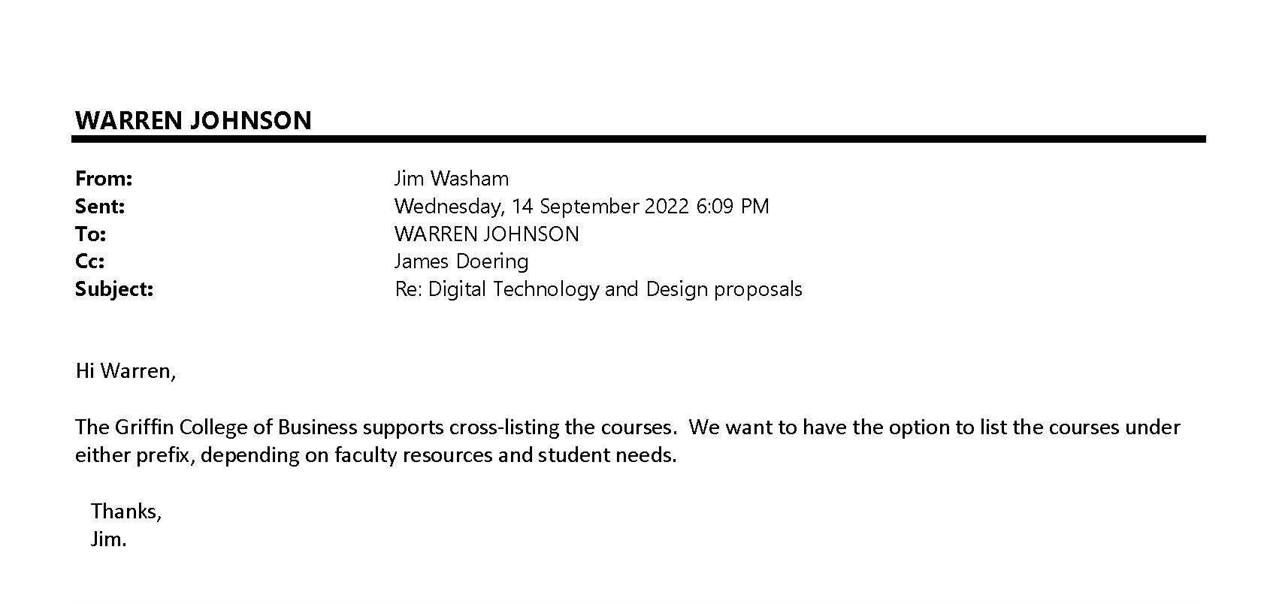

Appendix B
Approval of program from College of Engineering and Computer Science

