For Academic Affairs and Research Use Only
CIP Code:
Degree Code:

Bulletin / Banner Change Transmittal Form
[x] Undergraduate Curriculum Council
[ ] Graduate Council
Signed paper copies of proposals submitted for consideration are no longer required. Please type approver name and enter date of approval.
Email completed proposals to curriculum@astate.edu for inclusion in curriculum committee agenda.
Department Curriculum Committee Chair | COPE Chair (if applicable)
  Sharon D. James | 3/20/2018
  __________________ | Enter date
Department Chair: | Head of Unit (If applicable)
  Melodie Philhours | 3/21/2018
  __________________ | Enter date
College Curriculum Committee Chair (M. Hill) | Undergraduate Curriculum Council Chair
   | 3/26/2018
  __________________ | Enter date
College Dean | Graduate Curriculum Committee Chair
  Jim Washam | 3/27/2018
  __________________ | Enter date
General Education Committee Chair (If applicable) | Vice Chancellor for Academic Affairs
  __________________ | Enter date
  __________________ | Enter date

1.Contact Person (Name, Email Address, Phone Number)
Dr. Melodie Philhours, mphil@astate.edu, 870-680-8148

2.Proposed Change
- Change name of IB 4283 Internship in International Business Studies to IB 4283 Internship in International Business in Course Description (p. 444) and change IB 4283 International Business Practicum to IB 4283 Internship in International Business in degree plan (p. 169) for consistency.

- Change frequency to: Fall, Spring, Summer.

3.Effective Date
Fall 2018

4.Justification – Please provide details as to why this change is necessary.
Name of course should be consistent across the bulletin. No one recalls the origin of these differing names.

Bulletin Changes

Instructions
Please visit http://www.astate.edu/a/registrar/students/bulletins/index.dot and select the most recent version of the bulletin. Copy and paste all bulletin pages this proposal affects below. Follow the following guidelines for indicating necessary changes.

*Please note: Courses are often listed in multiple sections of the bulletin. To ensure that all affected sections have been located, please search the bulletin (ctrl+F) for the appropriate courses before submission of this form.

- Deleted courses/credit hours should be marked with a red strike-through (red strikethrough)
- New credit hours and text changes should be listed in blue using enlarged font (blue using enlarged font).
- Any new courses should be listed in blue bold italics using enlarged font (blue bold italics using enlarged font)

You can easily apply any of these changes by selecting the example text in the instructions above, double-clicking the ‘format painter’ icon , and selecting the text you would like to apply the change to.
Please visit https://youtu.be/yjdL2n4lZm4 for more detailed instructions.

p. 169
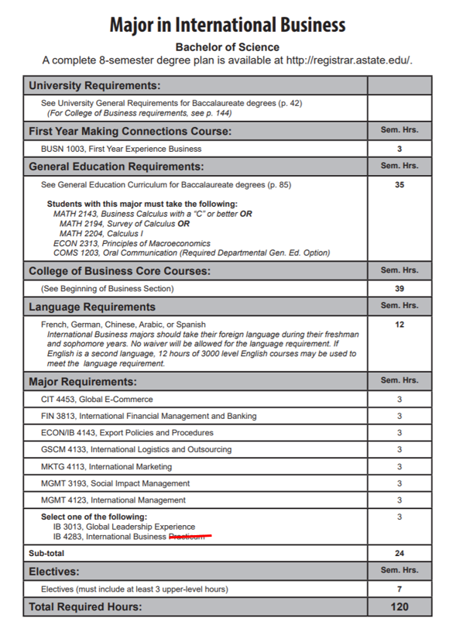

Internship in International Business

p. 172
Major in Management
Bachelor of Science
Emphasis in International Business
A complete 8-semester degree plan is available at http://registrar.astate.edu/.

University Requirements:
See University General Requirements for Baccalaureate degrees (p. 41)
(For College of Business requirements, see p. 143)
First Year Making Connections Course: | Sem. Hrs.
BUSN 1003, First Year Experience Business | 3
General Education Requirements: | Sem. Hrs.
See General Education Curriculum for Baccalaureate degrees (p. 84)  Students with this major must take the following:  MATH 2143, Business Calculus with a “C” or better OR  MATH 2194, Survey of Calculus OR  MATH 2204, Calculus I  ECON 2313, Principles of Macroeconomics  COMS 1203, Oral Communication (Required Departmental Gen. Ed. Option) | 35
College of Business Core Courses: | Sem. Hrs.
(See Beginning of Business Section) | 39
Major Requirements: | Sem. Hrs.
MGMT 3143, Human Resource Management | 3
MGMT 3153, Organizational Behavior | 3
MGMT 3613, Leadership | 3
MGMT 4163, Small Business Management | 3
MKTG 3023, Applied Research | 3
Sub-total | 15
Emphasis Area (International Business): | Sem. Hrs.
ECON/IB 4143, Export Policies & Procedures | 3
FIN 3813, International Financial Management and Banking | 3
GSCM 4133, International Logistics and Outsourcing | 3
MGMT 4123, International Management | 3
MKTG 4113, International Marketing | 3
Select one of the following:  CIT 4453, Global E-Commerce  ECON 4103, International Trade  ECON 4363, Global Environmental Policies  IB 3013, Global Leadership  IB 4133, International Law  IB 4283, Internship in International Business Studies  MGMT 3193, Social Impact Management | 3
Sub-total | 18
Electives: | Sem. Hrs.
Electives | 10
Total Required Hours: | 120

Page 173
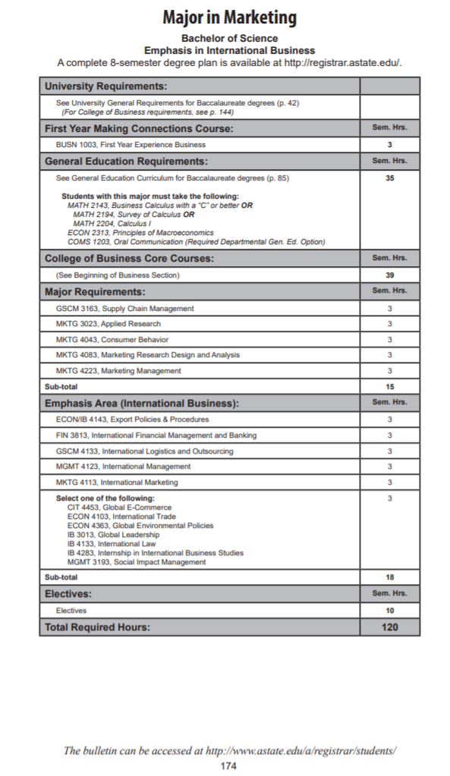

IB 4283. Internship in International Business Studies Supervised work experience with a firm in a foreign country, the international division of a firm in the United States, an international institution, or a government agency dealing with international business or foreign relations. Provides a practical experience for international business students. Prerequisite, junior or senior classification and consent of instructor. Demand. Fall, Spring, Summer.

