For Academic Affairs and Research Use Only
Proposal Number | BU12
CIP Code:
Degree Code:

Program Modification Form
[ X] Undergraduate Curriculum Council
[ ] Graduate Council
Modification Type: [ ]Admissions, [ X]Curricular Sequence, or [ ]Other

Signed paper copies of proposals submitted for consideration are no longer required. Please type approver name and enter date of approval.

Department Curriculum Committee Chair | COPE Chair (if applicable)
  H. Steve Leslie | 2/21/2022
  __________________ | Enter date
Department Chair | Head of Unit (if applicable)
  Bill Hu | 2/28/2022
  __________________ | Enter date
College Curriculum Committee Chair | Undergraduate Curriculum Council Chair
  John Robertson | 3/11/2022
  __________________ | Enter date
Director of Assessment (only for changes impacting assessment) | Graduate Curriculum Committee Chair
  __________________ | Enter date
  __________________ | Enter date
College Dean | Vice Chancellor for Academic Affairs
  Jim Washam | 3/25/2022
  __________________ | Enter date
__________________ | Enter date
General Education Committee Chair (if applicable)

- Contact Person (Name, Email Address, Phone Number)
Dr. Melodie Philhours
mphil@astate.edu
870-680-8148

- Proposed Change (for undergraduate curricular changes please provide an 8-semester plan (appendix A), if applicable)
Remove GSCM 3163 Supply Chain Management from BS Marketing core requirements and add 3 hours free elective.

- Effective Date
Fall 2022

- Justification – Please provide details as to why this change is necessary.
GSCM 3163 Supply Chain Management is moving to the NGCOB core requirements. All students, including marketing majors, take the core and thus GSCM 3163 becomes redundant in the core marketing requirements.

Bulletin Changes

Instructions
Please visit http://www.astate.edu/a/registrar/students/bulletins/index.dot and select the most recent version of the bulletin. Copy and paste all bulletin pages this proposal affects below. Please include a before (with changed areas highlighted) and after of all affected sections.

*Please note: Courses are often listed in multiple sections of the bulletin. To ensure that all affected sections have been located, please search the bulletin (ctrl+F) for the appropriate courses before submission of this form.

Page 152: Before

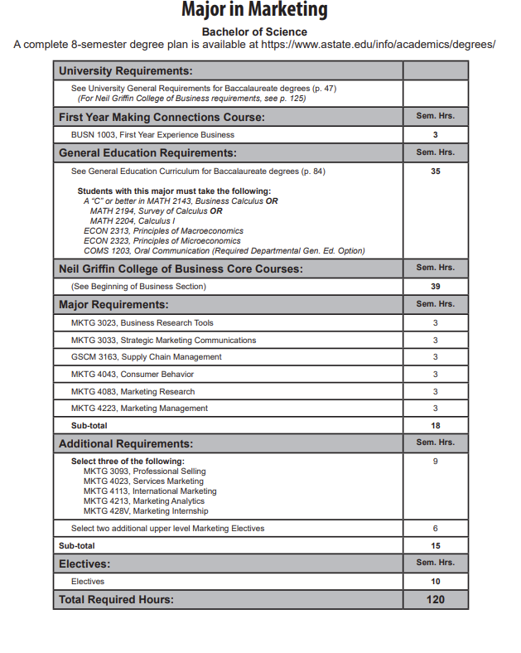

Page 152 AFTER:

13
15

Appendix A, 8-Semester Plan
(Referenced in #2 - Undergraduate Proposals Only)

