Code # Enter text…
Letter of Notifications
[X] Undergraduate Curriculum Council
[ ] Graduate Council
Signed paper copies of proposals submitted for consideration are no longer required. Please type approver name and enter date of approval.
Email completed proposals to curriculum@astate.edu for inclusion in curriculum committee agenda.
Department Curriculum Committee Chair | COPE Chair (if applicable)
  Shelley Gipson | 8.30.17
  __________________ | Enter date
Department Chair: | Head of Unit (If applicable)
  Temma Balducci | 9/8/2017
  __________________ | Enter date
College Curriculum Committee Chair | Undergraduate Curriculum Council Chair
  Warren Johnson | 9/27/2017
  __________________ | Enter date
College Dean | Graduate Curriculum Committee Chair
  Gina Hogue | 9/27/2017
  __________________ | Enter date
General Education Committee Chair (If applicable) | Vice Chancellor for Academic Affairs
  __________________ | Enter date
  __________________ | Enter date

If you require to fill out a Letter of Notification, please email curriculum@astate.edu or contact Academic Affairs and Research at (870) 972-2030 for guidance PRIOR TO submitting these through the curricular process.

1.Contact Person (Name, Email Address, Phone Number)
Dr. Temma Balducci, tbalducci@astate.edu, 870.972.3050

Bulletin Changes

Instructions
Please visit http://www.astate.edu/a/registrar/students/bulletins/index.dot and select the most recent version of the bulletin. Copy and paste all bulletin pages this proposal affects below. Follow the following guidelines for indicating necessary changes.

*Please note: Courses are often listed in multiple sections of the bulletin. To ensure that all affected sections have been located, please search the bulletin (ctrl+F) for the appropriate courses before submission of this form.

- Deleted courses/credit hours should be marked with a red strike-through (red strikethrough)
- New credit hours and text changes should be listed in blue using enlarged font (blue using enlarged font).
- Any new courses should be listed in blue bold italics using enlarged font (blue bold italics using enlarged font)

You can easily apply any of these changes by selecting the example text in the instructions above, double-clicking the ‘format painter’ icon , and selecting the text you would like to apply the change to.
Please visit https://youtu.be/yjdL2n4lZm4 for more detailed instructions.

ASU – J 2017-18 Undergraduate Bulletin, Page 76 –
A Certificate in Museum Studies is awarded upon successful completion of 21 hours of
specific coursework. This program requires admission to the university. For more information, see the
College of Liberal Arts and Communication section of this bulletin.

A Certificate in Social Media Management is awarded upon successful completion of 12 hours of
specific coursework. This program requires admission to the university. For more information, see the
College of Liberal Arts and Communication section of this bulletin.

ASU – J 2017-18 Undergraduate Bulletin, Page 203, last sentence –
The College provides Associate of Applied Science degrees in Crime Scene Investigation, Law Enforcement Administration, and Law Enforcement and a certificates in Museum Studies and Social Media Management. It also provides pre-professional advisement for law school as part of its Political Science, Philosophy, History, and Criminology majors.

ASU – J 2017-18 Undergraduate Bulletin, Page 205 –

MISSION STATEMENT
The Department of Art and Design is dedicated to the creative, aesthetic and cultural development of visual art students that builds upon a well-rounded liberal arts education. The faculty prepares its students to assume leadership positions in their professional lives while maintaining a commitment to the conceptual and aesthetic standards of their chosen discipline. The department develops and supports a nurturing creative community that builds confidence through academic rigor and provides an environment in which students can build and refine their craft, develop critical thinking skills, and realize their full potential. Graduates of the Department of Art and Design join the community as socially responsible artists, designers, educators and historians ready to contribute to diverse and changing creative fields.

The Bachelor of Arts degree provides a liberal arts-fine arts education in art history. Art history provides practice in analysis, interpretation, critical thinking, and writing skills. This degree is good preparation for a student planning to work toward an advanced degree in art history. A certificate in Museum Studies is also available to help students prepare for a job in a variety of museum fields.
.
The Bachelor of Fine Arts degree programs are designed to prepare students for professional careers as a classroom art teacher, graphic designer, or studio artist. The BFA in Graphic Design, the BFA in Graphic Design (with emphasis in Digital Design) or the BFA in Art (with emphasis in Studio Art or Art Education) is the initial professional degree, and it is the requisite degree for the student who plans to pursue a studio-oriented post-baccalaureate degree.

No grade below C in courses with an ART/ARTH/ARED prefix may be applied to the Bachelor of Fine Arts Degree. A cumulative 2.75 GPA (or higher) in all courses with an ART/ARTH/ARED prefix is
required for the BFA degree

2017-2018 ASU-J Undergraduate Bulletin, page 207
Major in Art (cont.)
Bachelor of Arts
Emphasis in Art History
A complete 8-semester degree plan is available at http://registrar.astate.edu/.
Select one Philosophy Elective from the following:  PHIL 3313, Philosophy of Religion PHIL 3623, Eastern Philosophy PHIL 4723, Aesthetics | 3
Select one Anthropology Elective from the following:  ANTH 2233, Intro to Cultural Anthropology  (cannot satisfy both general education and Anthropology elective)  ANTH 3203, Intro to Archaeology | 3
Select two Studio Art or Art Education Electives from the following:  ARED 3803, Teaching Art in the Elementary Grades ART 3033, Drawing III  ART 3063, Painting  ART 3083, Printmaking  ART 3093, Ceramics ART 3103, Sculpture ART 3403, Photography | 6
Select one Theatre Elective from the following:  THEA 1223, Principles of Stage Design THEA 2223, Fundamentals of Stagecraft THEA 2243, Costume Construction THEA 2263, Fashion History | 3
Sub-total | 46
Electives: | Sem. Hrs.
Electives | 9-15
Total Required Hours: | 120

Certificate in Museum Studies
The certificate in Museum Studies is designed to give practical experience in the study of cultural objects and an understanding of the departments, tasks, and current methods of a working museum for students who are interested in pursuing a career in a museum.

Select one Anthropology Elective from the following no used in General Education:  ANTH 2233, Introduction to Cultural Anthropology or ANTH 3203, Introduction to Archaeology | 3
Select two Electives from the following:  ANTH 3233, Native American Culture in the Mid South  ARTH 3013, Egyptian and Near Eastern Art and Architecture  ARTH 3023, Greek and Roman Art and Architecture  ARTH 3033, Late Antique and Eastern Mediterranean Art and Architecture  ARTH 3043, Asian Art and Architecture  ARTH 3053, Medieval and Renaissance Art and Architecture  ARTH 3063, Baroque and Rococo Art and Architecture  ARTH 3073, Nineteenth Century Art and Architecture  ARTH 3083, Twentieth Century Art and Architecture  ARTH 3093, Global Contemporary Art 1980 to Present  ENG 3613, Introduction to Folklore  ENG 3623, American Folklore  ENG 3633, Native American Verbal Art  ENG 3643, African-American Folklore  HIST 3013, Civilizations of Africa  HIST 3043, Asian History Since 1500  HIST 3083, History of Arkansas  HIST 3123, Latin America, The Colonial Period  HIST 3133, Latin America, The National Period  HIST 3173, Classical Mediterranean Civilization  HIST 3183, Medieval Europe  HIST 3193, The Crusades  HIST 3223, Renaissance and Reformation Europe  HIST 3253, Modern Europe, 1750 to 1870  HIST 3273, The Age of Crisis. Europe 1870 to Present  HIST 3283, Society and Thought in Europe  HIST 3303, The Modern History of the Middle East 1800 to the Present  HIST 3323, United States Environmental History  HIST 3333, The Practice of History  HIST 3483, The United States from 1917-1941  HIST 3493, The United States Since 1945  HIST 3503, U.S. Foreign Relations since 1900  HIST 3563, Constitutional History of the United States  HIST 3603, The American South  HIST 3623, The American West  HIST 3653, The American Indian  HIST 3673, African American History I  HIST 3683, African American History II  HIST 3693, United States Women’s History  HIST 3743, The Urban Revolution in America  HIST 3853, U.S. Civil Rights Movement | 6
ARTH 4013, History of the Museum and Collecting | 3
ARTM 4023, Museum Fundamentals I: Collections Management and Museum Law | 3
ARTM 4033, Museum Fundamentals II: Exhibition Seminar | 3
ARTH 4113, Museum Internship | 3
Total Required Hours: | 21

2017-2018 ASU-J Undergraduate Bulletin, page 473
ARTH 4803. Art Theory and Criticism This course develops a link between art criticism and studio practice, relating contemporary art production and critical theory. Includes written reports and oral presentations concerning methodology and results of research. Prerequisites, a grade of CR in ART 3330; a minimum of 48 hours ART/ARTH courses; or permission of instructor. Spring.
ARTH 4894. Advanced Research Research and writing of an art historical essay that proves an original thesis; to be completed in the final semester. Restricted to BA in Art, Art History emphasis majors. Prerequisites, 2.75 GPA in all ART/ARED/ARTH courses, a grade of “Credit” in ARTH 2890 and ARTH 3890, 12 hours of ARTH and permission of instructor. Fall, Spring.
MUSEUM STUDIES
ARTM 4023. Museum Fundamentals I: Collections Management and Museum Law. Instruction and hands-on practice in managing historical and anthropological collections, including object-handling, accessioning, deaccessioning, cataloguing, loans, valuating collections, conservation environments, registration transactions and forms, museum law and policies. Prerequisite: junior level standing or permission of instructor. Fall, even.

ARTM 4033. Museum Fundamentals II: Exhibition Seminar. Hands-on practice in exhibit development and production, including topic and object selection, curatorial research, mocking up, label writing, and basic program evaluation. Prerequisite: junior level standing or permission of instructor. Spring, odd.

Arkansas State University
Office of Assessment
Museum Studies Certificate
Expected Outcomes  (Column 1) | Assessment Procedures Criterion  (Column 2) | Which courses are responsible for this outcome?  (Column 3) | Assessment  Timetable  (Column 4) | Who is responsible for assessing and reporting on the results?  (Column 5)
SWBAT communicate knowledgeably about diverse aspects of museum practice including history and organization, collection management, conservation, and curation. | DIRECT –  Student will present a portfolio of work that includes two written assignments, and work from their individual exhibition project (labels, project research, and exhibition installation photography)  INDIRECT – Student Survey during Exit Interview at end of internship, Alumni survey of all graduates every three years. | 3000-level ANTH, ARTH, HIST (-law), or Folklore (ENG);  3000-level ANTH, ARTH, HIST (-law), or Folklore (ENG);  ANTH 2233 Introduction to Cultural Anthropology or ANTH 3203 – Introduction to Archaeology;  ARTH 4013 History of Museums Collecting;  ARTM 4043 Museum Fundamentals I;  ARTM 4053 Museum Fundamentals II;  ARTH 401V Museum Internship | Assessed during Internship  Year 1: 18-19 | Faculty report to assessment committee and curriculum committee
SWBAT design an exhibition based on a specific topic, that includes all curator and preparator duties. | DIRECT –  Student will present a portfolio of work that includes two written assignments, and work from their individual exhibition project (labels, project research, and exhibition installation photography)  INDIRECT – Student Survey during Exit Interview at end of internship, Alumni survey of all graduates every three years. | 3000-level ANTH, ARTH, HIST (-law), or Folklore (ENG);  3000-level ANTH, ARTH, HIST (-law), or Folklore (ENG);  ANTH 2233 Introduction to Cultural Anthropology or ANTH 3203 – Introduction to Archaeology;  ARTH 4013 History of Museums Collecting;  ARTM 4043 Museum Fundamentals I;  ARTM 4053 Museum Fundamentals II;  ARTH 401V Museum Internship | Assessed during Internship  Year 2: 19-20 | Faculty report to assessment committee and curriculum committee
SWBAT successfully apply critical thinking skills in museum-based art criticism. | DIRECT – Students successfully complete an exhibition criticism paper in Internship.  INDIRECT – Student Survey during Exit Interview at end of internship, Alumni survey of all graduates every three years. | 3000-level ANTH, ARTH, HIST (-law), or Folklore (ENG);  3000-level ANTH, ARTH, HIST (-law), or Folklore (ENG);  ANTH 2233 Introduction to Cultural Anthropology or ANTH 3203 – Introduction to Archaeology;  ARTH 4013 History of Museums Collecting;  ARTM 4043 Museum Fundamentals I;  ARTM 4053 Museum Fundamentals II;  ARTH 401V Museum Internship | Assessed during Internship  Year 3: 20-21 | Faculty report to assessment committee and curriculum committee

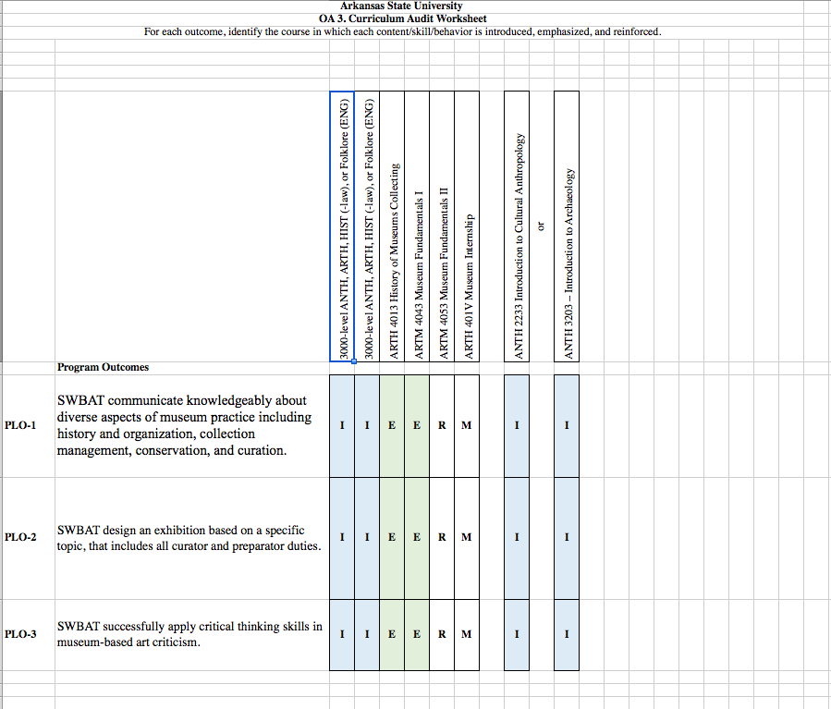

LETTER OF NOTIFICATION – 8

UNDERGRADUATE CERTIFICATE PROGRAM
(6-21 SEMESTER CREDIT HOURS)

1. Institution submitting request: Arkansas State University-Jonesboro

- Contact person/title: Temma Balducci

- Phone number/e-mail address: 870.972.3746/tbalducci@astate.edu

- Proposed effective date: Spring 2018

- Name of proposed Undergraduate Certificate Program (Program must consist of 6-21 semester credit hours): Museum Studies Certificate

- Proposed CIP Code: Registrar’s Office provides

- Reason for proposed program implementation: The certificate is designed to give practical and hands-on experience for students who are interested in pursuing a career in the museum field. It will provide enrollees with a grounding in the study of cultural objects and an understanding of the departments, tasks, and current methods of a working museum.

- Provide the following:
    - Curriculum outline - List of courses in new program – Underline required courses
ANTH 2233 – Introduction to Cultural Anthropology
OR ANTH 3203 Intro to Archaeology
3000-level – in area of interest (art history, history, archaeology, etc.)
3000-level – in area of interest (art history, history, archaeology, etc.)
ARTH 4013 – History of the Museum and Collecting
ARTM 4023 – Museum Fundamentals I: Collections Management
and Museum Law
ARTM 4033 – Museum Fundamentals II: Exhibition Seminar
ARTH 4113 – Museum Internship
    - Total semester credit hours required for proposed program
(Program range: 6-21 semester credit hours) 21 hrs

    - New courses and new course descriptions:

ARTM 4023 – Museum Fundamentals I: Collections Management and Museum Law
Instruction and hands-on practice in managing historical and anthropological collections, including object-handling, accessioning, deaccessioning, cataloguing, loans, valuating collections, conservation environments, registration transactions and forms, museum law and policies.
ARTM 4033 – Museum Fundamentals II: Exhibition Seminar Hands-on practice in exhibit
development and production, including topic and object selection,
curatorial research, mocking up, label writing, and basic program
evaluation.

    - Program goals and objectives: The Museum Studies Certificate will 1. Introduce students to the history, departments, tasks, and current methods of a working museum 2. Reinforce knowledge of the museum field through practical and hands-on experience within the museum environment and through the study of cultural objects 3. Require the students to show mastery of the material through research and critique

    - Expected student learning outcomes: Students will be able to 1. communicate knowledgeably about diverse aspects of museum practice including history and organization, collection management, conservation, and curation 2. design an exhibition based on a specific topic that includes all curator and preparator duties 3. utilize critical thinking skills in museum-based art criticism

    - Documentation that program meets employer needs: See Attached.
    - Student demand (projected enrollment) for proposed program: from an informal student poll conducted May 3-5, 2017, there were 25 ASTATE students who wanted to pursue a Museum Studies certificate
    - Program approval letter from licensure/certification entity, if required. This certificate will go through NASAD after University level approval. Though it is not required, it is the intent of the Faculty to have it approved by NASAD during the Spring of 2018
    - Name of institutions offering similar programs and the institution(s) used as model to develop proposed program: Boston University, Ohio University, Harvard University
    - Scheduled program review date (within 10 years of program implementation): 2025

- Institutional curriculum committee review/approval date:

- Will this program be offered on-campus, off-campus, or via distance delivery? If yes, indicate mode of distance delivery. Mark *distance technology courses. On-campus for all courses. The internship course will have the option of being off campus.

- Identify off-campus location. Provide a copy of email notification to other institutions in the area of the proposed off-campus program offering.

- Provide additional program information if requested by ADHE staff.

President/Chancellor Approval Date:

Board of Trustees Notification Date:

Chief Academic Officer: Date:

