For Academic Affairs and Research Use Only
CIP Code:
Degree Code:

Reconfiguration of Existing Degree Program Proposal Form
[ ] Undergraduate Curriculum Council
[X] Graduate Council
Signed paper copies of proposals submitted for consideration are no longer required. Please type approver name and enter date of approval.
Email completed proposals to curriculum@astate.edu for inclusion in curriculum committee agenda.
Department Curriculum Committee Chair | COPE Chair (if applicable)
  Edward Hammerand | 9/27/2017
  __________________ | Enter date
Department Chair: | Head of Unit (If applicable)
  Hung-Chi Su | 9/27/2017
  __________________ | Enter date
College Curriculum Committee Chair | Undergraduate Curriculum Council Chair
  David F. Gilmore | 10/6/2017
  __________________ | Enter date
College Dean | Graduate Curriculum Committee Chair
  Anne A. Grippo | 10/6/2017
  __________________ | Enter date
General Education Committee Chair (If applicable) | Vice Chancellor for Academic Affairs
  __________________ | Enter date
  __________________ | Enter date

- Proposed Program Title
Graduate Certificate in Cyber Security
- Contact Person (Name, Email Address, Phone Number)
Dr. Hung-Chi Su, suh@astate.edu, 870-680-8119

- Proposed Starting Date
Spring 2018

- Is there differential tuition requested? If yes, please fill out the New Program/Tuition and Fees Change Form.
No
Bulletin Changes

Instructions
Please visit http://www.astate.edu/a/registrar/students/bulletins/index.dot and select the most recent version of the bulletin. Copy and paste all bulletin pages this proposal affects below. Follow the following guidelines for indicating necessary changes.

*Please note: Courses are often listed in multiple sections of the bulletin. To ensure that all affected sections have been located, please search the bulletin (ctrl+F) for the appropriate courses before submission of this form.

- Deleted courses/credit hours should be marked with a red strike-through (red strikethrough)
- New credit hours and text changes should be listed in blue using enlarged font (blue using enlarged font).
- Any new courses should be listed in blue bold italics using enlarged font (blue bold italics using enlarged font)

You can easily apply any of these changes by selecting the example text in the instructions above, double-clicking the ‘format painter’ icon , and selecting the text you would like to apply the change to.
Please visit https://youtu.be/yjdL2n4lZm4 for more detailed instructions.

*For new programs, please insert copy of all sections where this is referenced.*
Insert Page 52 of 2017-18 Graduate Bulletin:

GRADUATE CERTIFICATES
Addiction Studies
Aging Studies
Educational Leadership
—Building Level Administration
—Curriculum Director
—Gifted, Talented and Creative Director
—Instructional Specialist - Gifted, Talented
and Creative
—K-12 Special Education
—Special Education Director
Dyslexia Therapy
History
Health Care Management
Health Communication
Healthcare Emergency Management
Health Sciences Education
Clinical Mental Health Counseling
Nurse Educator
Play Therapy
Cyber Security

Insert Page 244 of 2017-18 Graduate Bulletin:

PROGRAMS OF STUDY

The College of Sciences and Mathematics offers work leading to the Master of Arts degree in biology; to the Master of Science degree with majors in biology, chemistry, computer science, environmental sciences, and mathematics; to the Master of Science in molecular biosciences; to the Master of Science in Education degree with majors in biology, chemistry, and mathematics; and to the Graduate Certificate in Cyber Security.

Insert Page 262 of 2017-18 Graduate Bulletin after Program of Study for Computer Science (but before Program of Study for the Master of Science in Environmental Sciences Degree on page 263):

Cyber Security
Graduate Certificate

University Requirements:
See Graduate School Degree Policies for additional information (p. 35)

Core Requirements: Sem. Hrs.
CS 6313, Data Security 3
CS 6323, Computer Security 3
CS 6333, Network and Internet Security 3

Electives: 6
Select six hours from the following:
CS 6123, Software Security
CS 6343, Cloud Security
LAW 6033, Cyberlaw and E-Commerce

Total Required Hours: 15

LETTER OF NOTIFICATION – 11
RECONFIGURATION OF EXISTING DEGREE PROGRAMS
(Consolidation or Separation of Degrees to Create New Degree)
*Please include the documents to be submitted found throughout this LON at the end of the form.

- Institution submitting request: Arkansas State University

- Contact person/title: Dr. Hung-Chi Su, Chair of Computer Science Department

- Title(s) of degree programs to be consolidated/reconfigured:
Master of Science in Computer Science

- Current CIP Code(s)/Current Degree Code(s): 11.0101

- Proposed title of consolidated/reconfigured program: Graduate Certificate in Cyber Security
- Proposed CIP Code for new program: 11.0101
- Proposed Effective Date: Spring 2018

- Reason for proposed program consolidation/reconfiguration:
(Indicate student demand (projected enrollment) for the proposed program and document that the program meets employer needs)

Reconfiguring the M.S. in Computer Science degree to create a graduate certificate in Cyber Security for students in the computer science program as well as non-degree seeking students. The courses will be pulled from the MS Computer Science Elective courses.
There is a rising demand for students who have expertise in Cybersecurity from corporations, nonprofit companies, and agencies. A digitally literate workforce using technology in a secure manner is imperative to these companies as well as the economy as a whole, and it provides security to an already critical infrastructure.
The projected enrollment will be 35 students per section.
According to NetworkWorld, there is a high demand for cybersecurity skill sets, however there is a shortage of individuals with these skills. “According to ESG (Enterprise Strategy Group) research, 46 percent of organizations say they have a ‘problematic shortage’ of cybersecurity skills in 2016.”
http://www.networkworld.com/article/3068177/security/high-demand-cybersecurity-skill-sets.html
According to the Colorado Springs Gazette there is a record 79 percent of American businesses who have reported a cybersecurity incident in 2014. Also, the 238,158 job postings for cyber security positions represented a 91% increase from 2010.
http://gazette.com/cybersecurity/education
According to the Bureau of Labor Statistics, the typical education required for an Information Security Analyst position is a Bachelor’s degree with a job outlook of 18% increase from 2014-2024.
http://www.bls.gov/ooh/computer-and-information-technology/information-security-analysts.htm

- Provide current and proposed curriculum outline by semester.
For undergraduate programs, please also fill out 8-semester plan at end of document.
Indicate total semester credit hours required for the proposed program. Underline new courses and provide new course descriptions. (If existing courses have been modified to create new courses, provide the course name/description for the current/existing courses and indicate the related new/modified courses.) Identify required general education core courses with an asterisk.
Current M.S. in Computer Science Curriculum

M.S. Computer Science
Course Number | Course Title | Credit Hours
CS 5713 | Analysis of Algorithms | 3
Select One of the Following
CS 5133 | Compiler | 3
CS 5723 | Automata Theory | 3
Select One of the Following
CS 5313 | Computer Networks | 3
CS 6213 | Parallel Processing
CS 6243  (pre fall 2017 #s were 6233 & 6823) | Distributed Systems
CS 6253  (pre fall 2017 #s were 6223 & 6823) | Heterogeneous Computing  (pre fall 2017 name was High Performance Computing)
Computer Science Electives (Choose 18 hours)
 | including CS courses such as:  CS 6313 Data Security  CS 6323 Computer Security  CS 6333 Network and Internet Security  CS 6123 Software Security  CS 6343 Cloud Security | 18
CS/MATH/STAT Electives (Choose 6 hours)
CS/MATH/STAT Elective |  | 6
CS/MATH/STAT Elective |  | 6
Proposed Graduate Certificate in Cyber Security

Course Number | Course Title | Credit Hours
Semester 1
CS 6313 | Data Security | 3
Semester 2
CS 6323 | Computer Security | 3
Semester 3
CS 6333 | Network and Internet Security | 3
Semester 4
Choose Two Electives (6 hours)
CS 6123 | Software Security | 6
CS 6343 | Cloud Security | 6
LAW 6033 | Cyberlaw and E-Commerce | 6
Total Credit Hours |  | 15
New/modified courses and course descriptions
- CS 6123, Software Security (originated as subject in previous undergraduate special course CS482V)
Study of security issues in the software development process, including security management, secure software development lifecycle, language security, and web application security.
- CS 6323, Computer Security (offered previously as part of a special topics subject, CS6823)
Survey of the latest security issues in computer systems, including topics such as authentication, access control, database security, operating system security, security management, and trust and privacy in computing.
- CS 6333, Network and Internet Security (offered previously as part of a special topics subject, CS6823)
Survey of network authentication, network access control, key management in networked systems, network security protocols, network security software and packages, and network security auditing.
- CS 6343, Cloud Security (offered previously as a special topics subject, CS6823)
Survey of the major security aspects of cloud computing and the corresponding mechanisms, including cloud security management, architecture and measurement as well as virtual machine security and real world cloud security examples.

- Provide program budget. Indicate amount of funds available for reallocation.
See end of document.

- Provide current and proposed organizational chart. See end of document.

- Institutional curriculum committee review/approval date: Enter text...

- Are the existing degrees offered off-campus or via distance delivery? No

- Will the proposed degree be offered on-campus, off-campus, or via distance delivery?
On-campus

- Identify mode of distance delivery or the off-campus location for the proposed program.
N/A

- Provide documentation that proposed program has received full approval by licensure/certification entity, if required.
(A program offered for teacher/education administrator licensure must be reviewed/approved by the Arkansas Department of Education prior to consideration by the Coordinating Board; therefore, the Education Protocol Form also must be submitted to ADHE along with the Letter of Notification).

N/A, program does not lead to licensure/certification

- Provide copy of e-mail notification to other institutions in the area of the proposed program and their responses; include your reply to the institutional responses. See end of document.

- List institutions offering similar program and identify the institutions used as a model to develop the proposed program.

Missouri State University – Cybersecurity Graduate Certificate
University of Memphis – Graduate Certificate in Cyber Security and Information Assurance
University of Missouri at St. Louis – Graduate Certificate in Cybersecurity
Model used to develop program was the A-State M.S. in Computer Science program

- Provide scheduled program review date (within 10 years of program implementation).
Spring 2028

- Provide additional program information if requested by ADHE staff.
Enter text...

President/Chancellor Approval Date: Click here to enter a date.
Board of Trustees Notification Date: Click here to enter a date.

Chief Academic officer: ___________________________________ Date: Enter date.
Name (printed): Click here to enter text.

8-Semester Plan
(referenced in #9 - Undergraduate Proposals Only)
Instructions: Please identify new courses in italics.
Arkansas State University-Jonesboro Degree:
Major:
Year:

Students requiring developmental course work based on low entrance exam scores (ACT, SAT, ASSET, COMPASS) may not be able to complete this program of study in eight (8) semesters. Developmental courses do not count toward total degree hours. Students having completed college level courses prior to enrollment will be assisted by their advisor in making appropriate substitutions. In most cases, general education courses may be interchanged between semesters. A minimum of 45 hours of upper division credit (3000-4000 level) is required for this degree.
Year 1 |  |  |  |  | Year 1
Fall Semester |  |  |  |  | Spring Semester
Course No. | Course Name | Hrs | Gen Ed |  | Course No. | Course Name | Hrs | Gen Ed
Total Hours |  |  |  |  | Total Hours
Year 2 |  |  |  |  | Year 2
Fall Semester |  |  |  |  | Spring Semester
Course No. | Course Name | Hrs | Gen Ed |  | Course No. | Course Name | Hrs | Gen Ed
Total Hours |  |  |  |  | Total Hours
Year 3 |  |  |  |  | Year 3
Fall Semester |  |  |  |  | Spring Semester
Course No. | Course Name | Hrs | Gen Ed |  | Course No. | Course Name | Hrs | Gen Ed
Total Hours |  |  |  |  | Total Hours
Year 4 |  |  |  |  | Year 4
Fall Semester |  |  |  |  | Spring Semester
Course No. | Course Name | Hrs | Gen Ed |  | Course No. | Course Name | Hrs | Gen Ed
Total Hours |  |  |  |  | Total Hours
Total Jr/Sr Hours ___ Total Degree Hours ___
Graduation Requirements:

Program Budget
(referenced in # 10)

Provide program budget. Indicate amount of funds available for reallocation.

All of the topics in the new courses involved have already been used in the course rotation as special topics; eliminating them as special topics while adding them to the bulletin as regular courses and adjusting the rotation accordingly results in no extra funds being required.

Organizational Chart
(referenced in # 11)

Provide current and proposed organizational chart. Include where the proposed program will be housed (department/college).

Organizational Chart will remain the same.
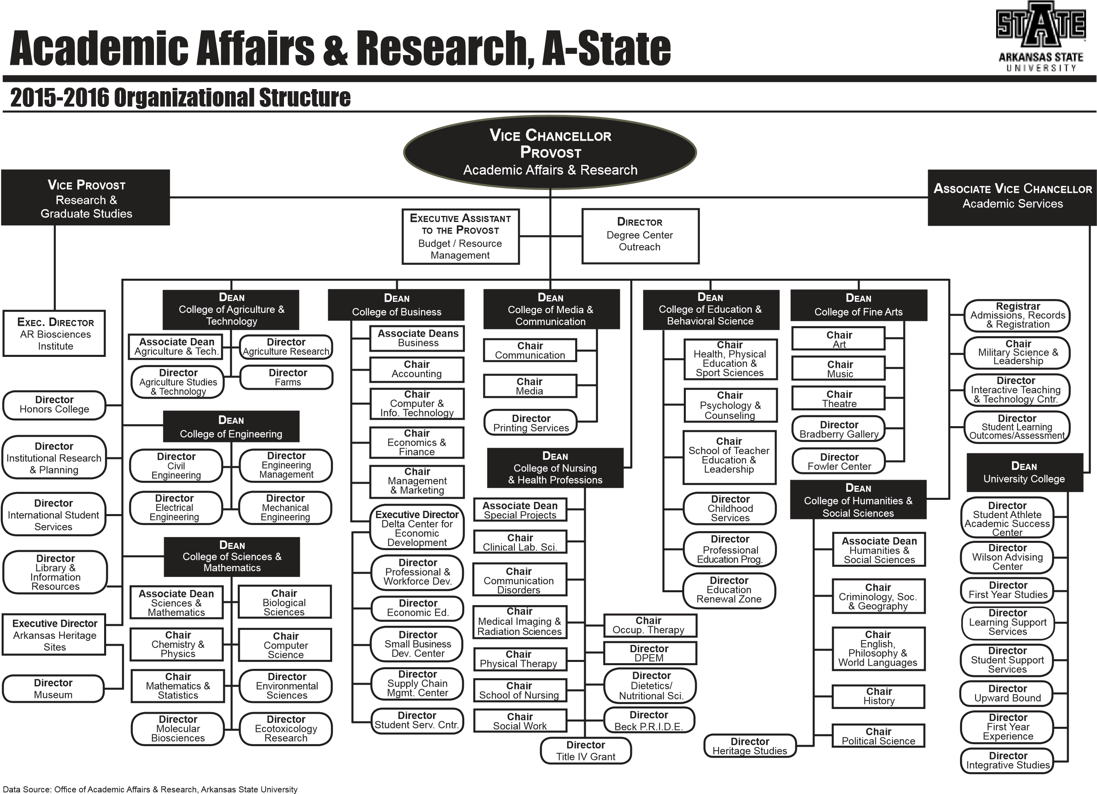

Written Notification to Other Institutions
(referenced in # 17)

This should include a copy of written notification to other institutions in area of proposed program and responses

According to the office of Vice Chancellor for Academic Affairs, this is not required for this certificate

Student Learning Outcomes
Provide outcomes that students will accomplish during or at completion of this reconfigured degree. Fill out the following table to develop a continuous improvement assessment process.
For further assistance, please see the ‘Expanded Instructions’ document available on the UCC - Forms website for guidance, or contact the Office of Assessment at 870-972-2989.
Note: Best practices suggest 4-7 outcomes per program; minors would have 1 to 4 outcomes.
Outcome 1 | A deeper understanding of the theory and application of cyber security algorithms and processes.
Assessment Procedure Criterion | Comprehensive examinations and employer surveys
Which courses are responsible for this outcome? | CS 6123, Software Security  CS 6313, Data Security  CS 6323, Computer Security  CS 6333, Network and Internet Security  CS 6343, Cloud Security
Assessment  Timetable | Comprehensive exams will be conducted each semester, reviewed annually, and reported on every three years; employer surveys will be conducted each fall and reported on every four years.
Who is responsible for assessing and reporting on the results? | Department assessment committee

Outcome 2 | The ability to apply cyber security analysis techniques to problem identification.
Assessment Procedure Criterion | Comprehensive examinations and employer surveys
Which courses are responsible for this outcome? | CS 6123, Software Security  CS 6313, Data Security  CS 6323, Computer Security  CS 6333, Network and Internet Security  CS 6343, Cloud Security  LAW 6033, Cyberlaw and E-Commerce
Assessment  Timetable | Comprehensive exams will be conducted each semester, reviewed annually, and reported on every three years; employer surveys will be conducted each fall and reported on every four years.
Who is responsible for assessing and reporting on the results? | Department assessment committee

Outcome 3 | The ability to apply cyber security implementation techniques to problem solution.
Assessment Procedure Criterion | Comprehensive examinations and employer surveys
Which courses are responsible for this outcome? | CS 6123, Software Security  CS 6313, Data Security  CS 6323, Computer Security  CS 6333, Network and Internet Security  CS 6343, Cloud Security
Assessment  Timetable | Comprehensive exams will be conducted each semester, reviewed annually, and reported on every three years; employer surveys will be conducted each fall and reported on every four years.
Who is responsible for assessing and reporting on the results? | Department assessment committee
Please repeat as necessary.

