For Academic Affairs and Research Use Only
Proposal Number: | NHP65
CIP Code:
Degree Code:

Course Deletion Proposal Form
[X] Undergraduate Curriculum Council
[ ] Graduate Council
Signed paper copies of proposals submitted for consideration are no longer required. Please type approver name and enter date of approval.

Department Curriculum Committee Chair | COPE Chair (if applicable)
  Kacie Altom | 10/28/2021
  __________________ | Enter date
Department Chair | Head of Unit (if applicable)
  Sarah Davidson, Associate Dean of Nursing | 10/28/2021
  Elizabeth Nix, BSN Chair | 10/28/2021
College Curriculum Committee Chair | Undergraduate Curriculum Council Chair
  Shanon Brantley | 10/28/2021
  __________________ | Enter date
College Dean | Graduate Curriculum Committee Chair
  Scott E. Gordon | 10/29/2021
  __________________ | Enter date
General Education Committee Chair (if applicable) | Vice Chancellor for Academic Affairs
  __________________ | Enter date
  Alan Utter | 11/16/2021

- Course Title, Prefix and Number
NRS 4713 Chronic Illness Nursing

- Contact Person (Name, Email Address, Phone Number)
Sarah Davidson, DNP, RN, CNE
sarahdavidson@astate.edu
870-972-2748

- Justification
After a review of NRS 4713 Chronic Illness Nursing and a review of Associate Degree Nursing curriculum, the faculty in the RN to BSN Program found that much of the information was repetitive.

- Last semester course will be offered
Fall 2021

- Yes Does this course appear in your curriculum? (if yes, and this deletion changes the curriculum, a Program Modification Form is required)
Yes, appropriate forms for curriculum modification accompany this form.

- No Is this course dual-listed (undergraduate/graduate)?
No

- No Is this course cross-listed with a course in another department?
If yes, which course(s)?
No

- No Is there currently a course listed in the Bulletin or Banner which is a one-to-one equivalent to this course (please check with the Registrar’s Office if unsure)?
If yes, which course?
No

Bulletin Changes

Instructions
Please visit http://www.astate.edu/a/registrar/students/bulletins/index.dot and select the most recent version of the bulletin. Copy and paste all bulletin pages this proposal affects below. Please include a before (with changed areas highlighted) and after of all affected sections.

*Please note: Courses are often listed in multiple sections of the bulletin. To ensure that all affected sections have been located, please search the bulletin (ctrl+F) for the appropriate courses before submission of this form.

Before
Bulletin Table 390
Please see next page
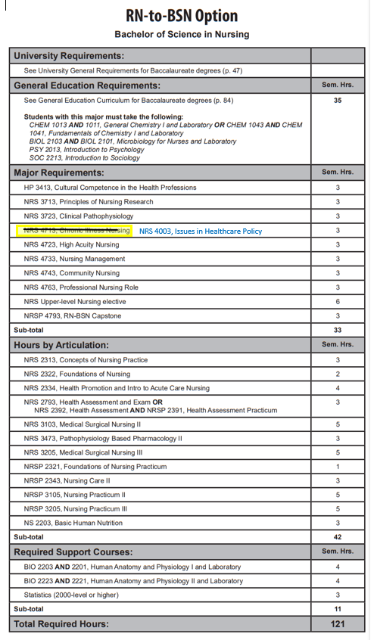
Before
Bulletin Page 568

NRS 4003. Issues in Healthcare Policy Introduction to the importance of healthcare policy and its influence on nursing practice while examining the nurse’s role in developing, implementing and improving health policy at all levels. Prerequisites, Admission to the RN-BSN program, C or better in NRS 3723 and NRS 3713. Fall, Spring, Summer.

NRS 4223. Forensic Nursing This course will introduce the beginning nurse to the field of forensic nursing. Content includes the recognition and management of forensic patients, both living and dead, and includes information on detection, collection, and preservation of evidence. Restricted to students who have completed 1 year of nursing coursework in either the AASN or BSN program, RN licensure, or instructor permission. Summer, odd.

NRS 4312. Chronic Illness and Rehabilitation Nursing Focus on clients with chronic illness throughout the lifespan. Concepts of gerontology and rehabilitation are integrated. Corequisites, NRS 4343, NRS 4362, and NRSP 4336. Fall, Spring.

NRS 4343. Professional Nursing Community Concepts of professional nursing practice expanded to the care of families and groups of clients in the community setting. Focuses also on change theory, group process strategies and professional and health care issues. Fall, Spring.

NRS 4393. Advanced Nutritional Concepts and Therapeutic Interventions Principles of nutritional support utilized in healthcare, including nutritional assessment, nutrient delivery and implications of disease. Prerequisites, completion of one year of nursing coursework, BSN junior level status, RN licensure, or instructor permission. Spring.

NRS 4424. Essentials of Medical Surgical Nursing III Continuation of concepts introduced in NRS 3345 Essentials of Medical Surgical Nursing II. Registration restricted to students who have been accepted to accelerated BSN option. Corequisites, NRS 3422, NRSP 3453. Spring.

NRS 4443. Essentials of High Acuity Nursing Focuses on patients with acute episodic health deviations which require ongoing diagnosis, immediate intervention or intensive nursing observation and care. Registration restricted to Students who are accepted to accelerated BSN option. Corequisites, NRS 4012, and NRSP 4433. Spring.

NRS 4481. Critical Decision Making and Testing Competencies in Nursing Further assists nursing students to identify areas for improving critical thinking skills and test taking skills. Will enhance the students ability to problem solve in providing complex care to individuals, groups, communities and populations. Prerequisites, senior nursing student status or instructor permission. Spring.

NRS 4542. Health Care Administration Introduction to the organization, operations and administration of a modern health care environment. Includes an introduction to health care delivery systems, decision making, and the management functions. Prerequisite, Admission to BSN program or graduate student enrolled in a CNHP program or any health related major. Fall, Spring.

NRS 4713. Chronic Illness Nursing Focus on clients with chronic illness throughout the lifespan. Concepts of gerontology, rehabilitation and spirituality are integrated. Prerequisites, Admission to the RN-BSN program, C or better in NRS 3723 and NRS 3713. Fall, Spring, Summer.

NRS 4723. High Acuity Nursing Focuses on patients with high acuity episodic or traumatic health deviations which require immediate intensive ongoing nursing diagnosis and interventions. Prerequisites, Admission to the RN-BSN program, C or better in NRS 3713 and NRS 3723. Fall, Spring, Summer.

NRS 4733. Nursing Leadership Managerial and leadership aspects of the nurse manager in various healthcare environments are discussed. Prerequisite, Admission to the RN-BSN Program, C or better in Statistics, NRS 3713. Fall, Spring, Summer.

NRS 4743. Public Health Nursing Concepts of professional nursing practice expanded to the care of families and groups of clients in the community setting. Focuses also on change theory, group process strategies and professional and health care issues. Prerequisites, Admission to the RN-BSN program, NRS 3723 and NRS 3713. Fall, Spring, Summer.

After
Bulletin Table pg 390
Please see next page
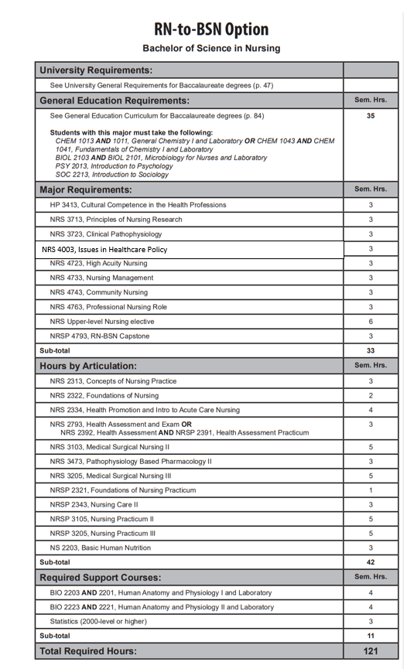
After
Bulletin Page 568

NRS 4003. Issues in Healthcare Policy Introduction to the importance of healthcare policy and its influence on nursing practice while examining the nurse’s role in developing, implementing and improving health policy at all levels. Prerequisites, Admission to the RN-BSN program, C or better in NRS 3723 and NRS 3713. Fall, Spring, Summer.

NRS 4223. Forensic Nursing This course will introduce the beginning nurse to the field of forensic nursing. Content includes the recognition and management of forensic patients, both living and dead, and includes information on detection, collection, and preservation of evidence. Restricted to students who have completed 1 year of nursing coursework in either the AASN or BSN program, RN licensure, or instructor permission. Summer, odd.

NRS 4312. Chronic Illness and Rehabilitation Nursing Focus on clients with chronic illness throughout the lifespan. Concepts of gerontology and rehabilitation are integrated. Corequisites, NRS 4343, NRS 4362, and NRSP 4336. Fall, Spring.

NRS 4343. Professional Nursing Community Concepts of professional nursing practice expanded to the care of families and groups of clients in the community setting. Focuses also on change theory, group process strategies and professional and health care issues. Fall, Spring.

NRS 4393. Advanced Nutritional Concepts and Therapeutic Interventions Principles of nutritional support utilized in healthcare, including nutritional assessment, nutrient delivery and implications of disease. Prerequisites, completion of one year of nursing coursework, BSN junior level status, RN licensure, or instructor permission. Spring.

NRS 4424. Essentials of Medical Surgical Nursing III Continuation of concepts introduced in NRS 3345 Essentials of Medical Surgical Nursing II. Registration restricted to students who have been accepted to accelerated BSN option. Corequisites, NRS 3422, NRSP 3453. Spring.

NRS 4443. Essentials of High Acuity Nursing Focuses on patients with acute episodic health deviations which require ongoing diagnosis, immediate intervention or intensive nursing observation and care. Registration restricted to Students who are accepted to accelerated BSN option. Corequisites, NRS 4012, and NRSP 4433. Spring.

NRS 4481. Critical Decision Making and Testing Competencies in Nursing Further assists nursing students to identify areas for improving critical thinking skills and test taking skills. Will enhance the students ability to problem solve in providing complex care to individuals, groups, communities and populations. Prerequisites, senior nursing student status or instructor permission. Spring.

NRS 4542. Health Care Administration Introduction to the organization, operations and administration of a modern health care environment. Includes an introduction to health care delivery systems, decision making, and the management functions. Prerequisite, Admission to BSN program or graduate student enrolled in a CNHP program or any health related major. Fall, Spring.

NRS 4723. High Acuity Nursing Focuses on patients with high acuity episodic or traumatic health deviations which require immediate intensive ongoing nursing diagnosis and interventions. Prerequisites, Admission to the RN-BSN program, C or better in NRS 3713 and NRS 3723. Fall, Spring, Summer.

NRS 4733. Nursing Leadership Managerial and leadership aspects of the nurse manager in various healthcare environments are discussed. Prerequisite, Admission to the RN-BSN Program, C or better in Statistics, NRS 3713. Fall, Spring, Summer.

NRS 4743. Public Health Nursing Concepts of professional nursing practice expanded to the care of families and groups of clients in the community setting. Focuses also on change theory, group process strategies and professional and health care issues. Prerequisites, Admission to the RN-BSN program, NRS 3723 and NRS 3713.

