You are required to reset your A-State password every 90 days. After you reset your password, follow these steps to change your Taleo Admin password:

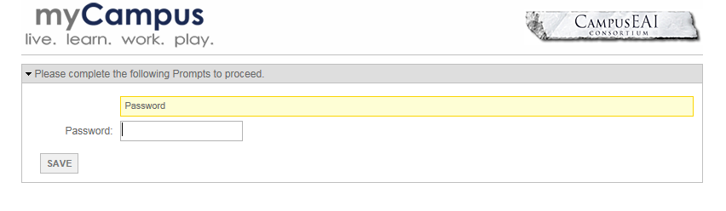
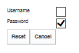
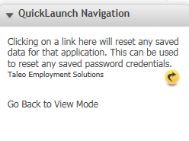
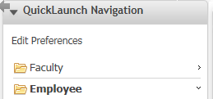
- Go back to the Employee folder and click on the Taleo Admin icon
- Enter your Password to login
Click on the yellow icon next to Taleo Employment Solutions
- Uncheck the Username checkbox
- Click Reset
- Click on Go Back to View Mode
Click on Edit Preferences

