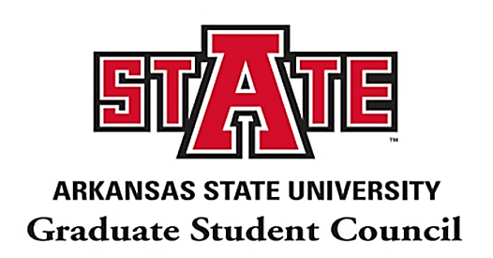
A-State Graduate Student Council Meeting Minutes
Monday, October 12th | 4:00PM – 5:00PM | Mockingbird Room, Reng Student Union

- The President Calls to Order at 04:00 PM (CST).

  - President reported on A-State Counseling and its benefits to improve mental health. She encouraged all students to visit the A-State website and gather necessary information about the A-State Counseling service. Later, she addressed the updated COVID-19 report of the county and presented the statistical analysis for Craighead County and Arkansas.

Also, she updated that the response was submitted to the Shared Governance Oversight Committee on Oct. 6th mentioning that there was no major opposition for the policy change proposed in “2020FA01: Simultaneous & Sequential Graduate Degrees.” She reported that the SGOC meeting scheduled on Friday, Oct. 9 was cancelled. Afterward, she recalled the announcement that the NAGPS South Central Leadership Nominations are still opened for following position:
      - Vice Chair
      - Director of Communications
      - Director of Outreach
      - Director of Legislative Affairs
      - Director of Advocacy
      - https://docs.google.com/forms/d/e/1FAIpQLScYjcno0aDmZZRsebUy7aIHW_piMUbhkQu5oG5xmsBzIsORuw/viewform

  - Vice President reported that the Health Insurance Open Forum will be held on October 20th in the Auditorium at 5:00 PM (CST) and 21st via Zoom at 5:00 PM (CST). She mentioned that a Health Insurance Agent may participate in the meeting. She added that the Zoom link will be on the GSC webpage as well. She encouraged all graduate students to nominate himself/herself or any research group of A-State to highlight their contribution and achievements in the monthly newsletter for November.

  - Treasurer reported on the current budget of the GSC. He also shared the possible plan in utilising the SGA action fund.

  - Communications Chair encouraged the students to follow our pages and share them with other students and with undergraduate students so that ASU students are motivated to start their Grad School in A-State. The links of our social media are given below:
- Instagram: @astategsc
- Facebook: A-State Graduate Student Council
Also, he reminded us about the virtual Bingo game where prizes will be given.

  - Outreach Chair reported on the Graduate School CV Workshop and the details are given below:
      - Thursday, October 15th, 2020 @ 3pm
      - Topic: Graduate School Workshop-CV Development https://astatecall.zoom.us/j/94031014616?pwd=SDBQbmlIWW1IQlpna1daSG1mS1cwZz09
      - Meeting ID: 940 3101 4616
      - Passcode: 119168
Also, she talked about the October 2020 NAGPS President’s Report Announcement.

II. Open Floor: No comments received from the participants.

III. President adjourned the meeting at 04:45 pm (CST).

…………………………………………………………………………………..

Contact Information: GSC Officers at 2020-2021 Academic Year

President: Alejandra Morales
E-mail: alejandr.morales@smail.astate.edu
Phone: 870-680-4818
Office: Reng Student Union, Suite 1909 (3rd Floor)

Vice-President: Sara Saucedo
E-mail: sara.saucedo@smail.astate.edu
Phone: 870-680-4818
Office: Reng Student Union, Suite 1909 (3rd Floor)

Secretary: Sumon Roy
Email: sumon.roy@smail.astate.edu
Phone: 870-680-4818
Office: Reng Student Union, Suite 1909 (3rd Floor)

Treasurer: Kyler Brinkley
Email: kyler.brinkley@smail.astate.edu
Phone: 870-680-4818
Office: Reng Student Union, Suite 1909 (3rd Floor)

Communications Chair: Jordan Shelton
Email: jordan.shelton1@smail.astate.edu
Phone: 870-680-4818
Office: Reng Student Union, Suite 1909 (3rd Floor)

Outreach Chair: Shanita Sanders
Email: shanita.sanders@smail.astate.edu
Phone: 870-680-4818
Office: Reng Student Union, Suite 1909 (3rd Floor)

